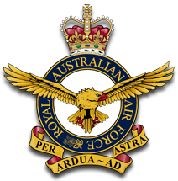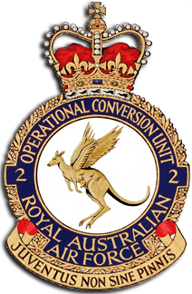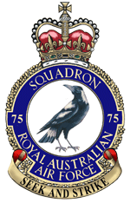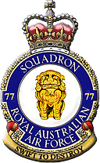
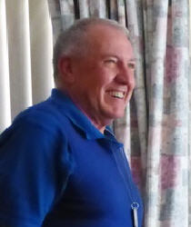
O56158 Squadron Leader Denis Patrick Macneall
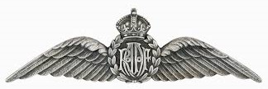
11 July 1945 - 12 July 2017
Aged 72 years
It is with the deepest regret that we advise our good friend and colleague, Denis Macneall, 'D-Mac', champion glider pilot and instructor, ex-avionics tech, 78 Pilots' Course, Mirage Pilot, QFI, Hash House Harrier, and all-round good bloke, passed away aged 72.
Denis began his service career in 1961 at RAAF Wagga as an Apprentice Instrument Fitter.
From 1964 until 1970, he worked as an Instrument Fitter in a number of postings including Hercules, No 38 Squadron Caribou (which included two eight -month tours in Vietnam) and with No 2 FTS in Pearce, WA.
In 1970 he was posted to No 78 Pilots' course, qualifying for posting to 'Fighters'.
He completed No2 OCU Fighter and Mirage Conversion Course by 1972 when he was posted to No 75 Squadron in Butterworth.
In 1974 Denis tackled the Flying Instructors' Course at Central Flying School, East Sale, which equipped him to take on two Instructional postings in both No 1 FTS, Point Cook (Winjeel) and No 2 FTS, Pearce (Macchi) until 1978 when he returned to Williamtown. Over the next six years he served with No 77 Squadron, No 2 OCU and as CO No 4 Flight.
In 1984, as a Qualified Flying Instructor, he was appointed Standardisation Officer and Flight Commander with No 2 FTS.
Denis retired from the RAAF in 1988 after 25 years service.
In 1989 he worked with CASA and became an Instructor in Saudi Arabia until 1992 following which he was Chief Flying Instructor with the Kalgoorlie Aero Club.
From 1994 to 2000 he held various positions with General Aviation and Airline training appointments.
In 1997 he was awarded a Bachelor of Science Degree in Computer Science.
Denis retired from fulltime work in 2000, retaining many interests with Gliding, GA, flying his Nanchang and running and owning Warbirds International.
DMac's funeral has just been announced:
• Pinnaroo Valley Memorial Park
• Whitfords Av, Padbury, WA, 6025
• Friday 21 July 12.30pm
• Medals may be worn

