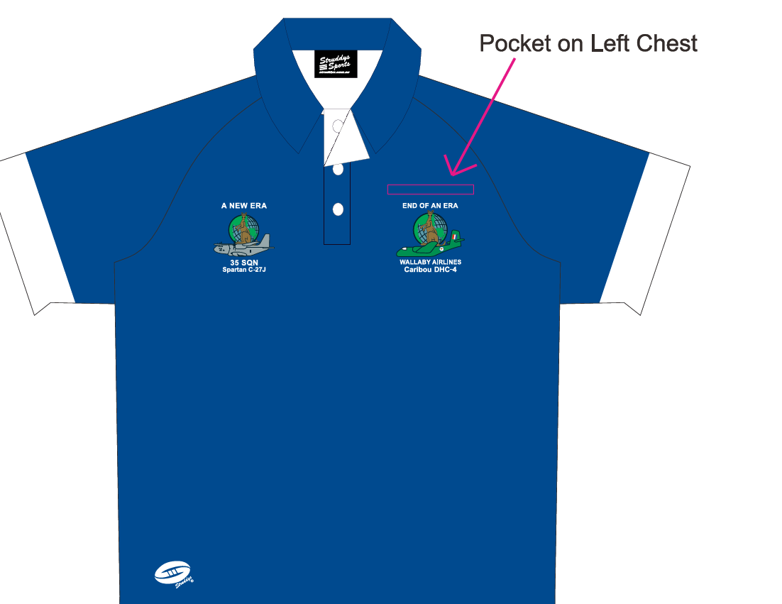
These Shirts sell for $50.00 postage not included I must order in lots of ten to get this price
There are four orders already

