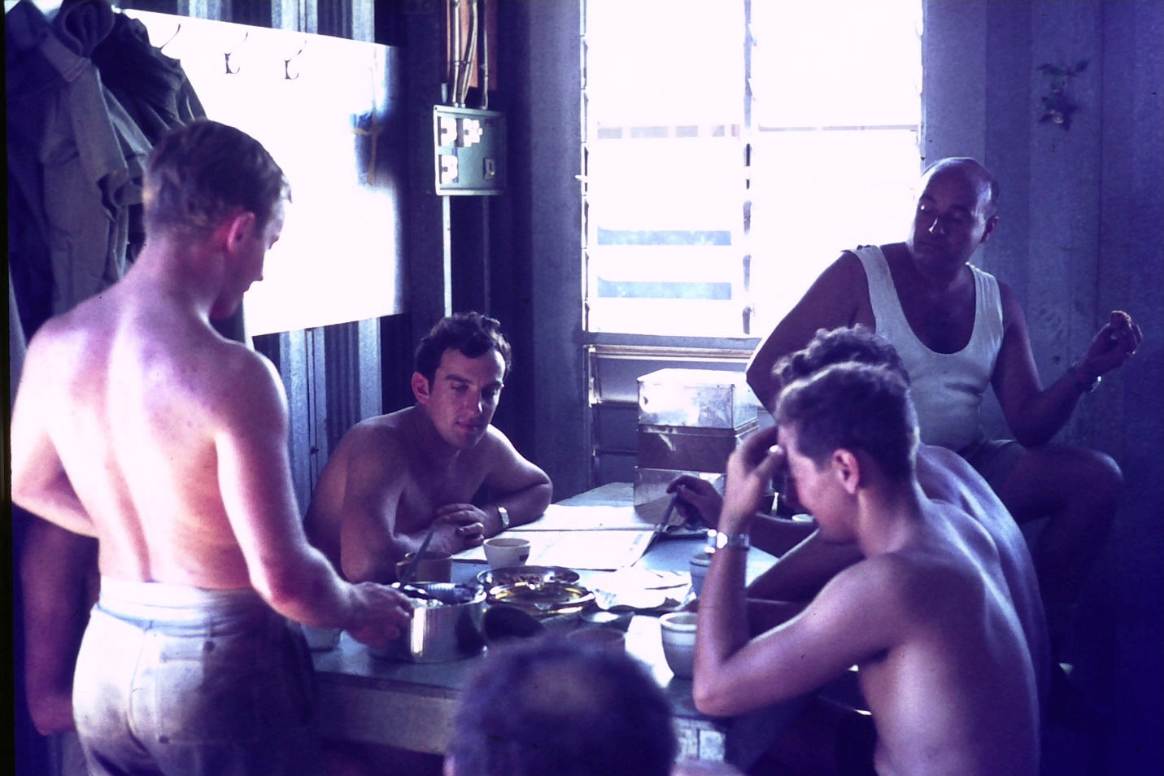

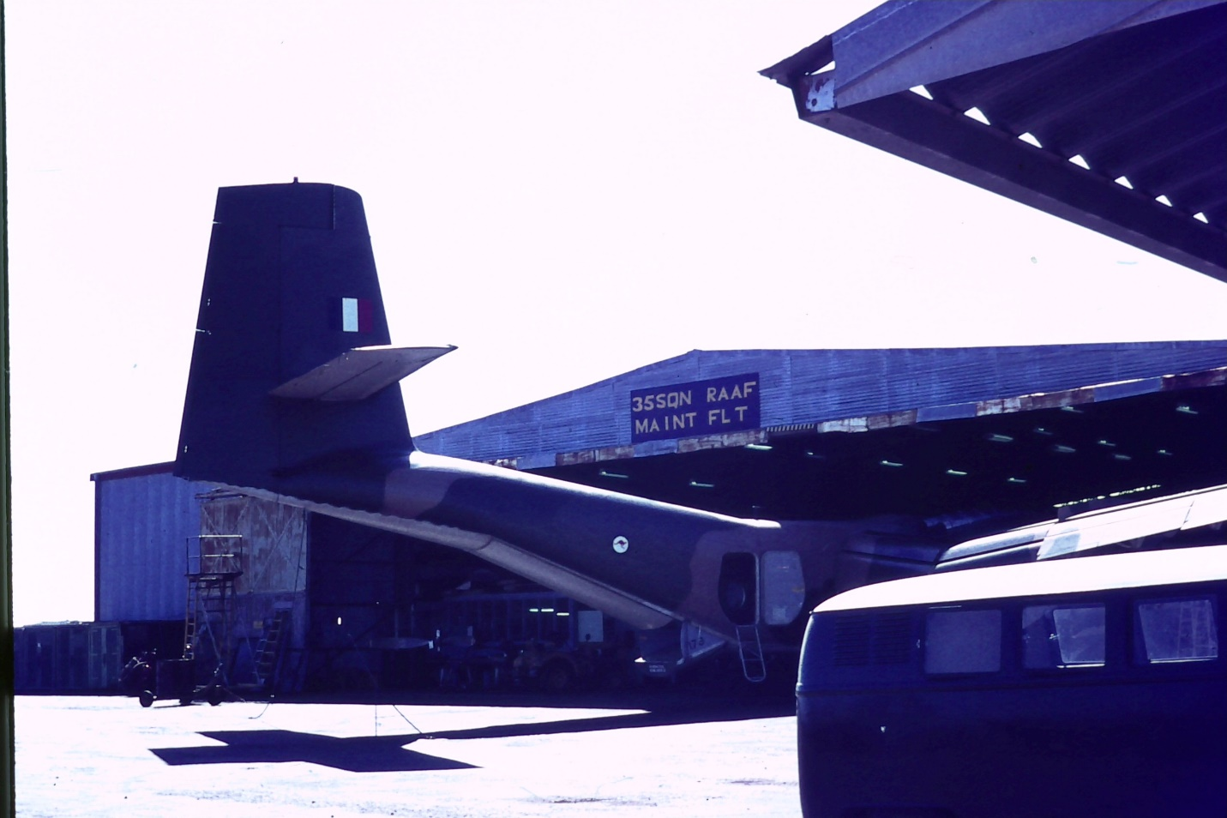

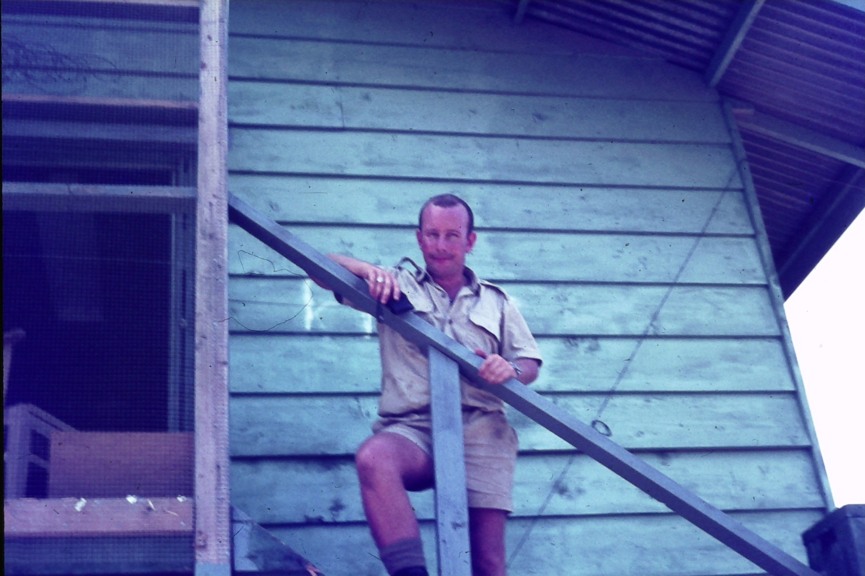

Peter Raymant

Top Left Metal workshop

Bottom left 35 Sqn Hangar

**Good to meet you last Saturday at the VVA National Museum. I have attached a couple of scanned slides that may be of interest to you !!!! 530 is in the 35 Sqn Metal Basher’s workshop, which I used to access a bit to use the guillotine's, sheet metal folders etc.  The middle one 090 is of me when Bks Sect used to stay on the top level of the 1OSU Barracks block, with the rest of the unit (minus the ADG’s). Later we set up a 6 person room in the old library on the ground floor. The other of course, is a 35 Sqn aircraft nose in to the Hangar.**

**Are you in touch with Dennis Window at all ? I have not seen him in ages, the last time being while at Tennant Creek on a Kangaroo Exercise. By that time I was a SSgt in the Army Reserve with a Movements Unit, and he was a FSgt with 1OSU, attached for the exercise.**

**Cheers Peter Raymant**