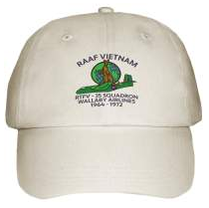
I will be order these caps they will sell for $20.00 i you wish to order a cap let me know and I will order it for you
sambo

