16 July 2018
Wallaby Lunch Club
We had seven who attended on 14 June. Jennie McIntosh from K.M. SMITH attended and enjoyed some of the stories. I obtained some books from Veterans’ Affairs and distributed them to everyone at the lunch. Wallaby Lunch Club 12 July, ten people attended including some A.D.G.s. Hopefully we will have more attending in future.
Calendar
I would like to do a yearly calendar from photos of each year with the Caribou as the background.
I will just put the names of each year of each month. It would be great to have a photo, but I have not received any photos except from John Barry of the “A” team 69/70.
John McDougall, Trevor Benneworth and John Sambrooks We had a meeting with Cassy Marshall, Community Support Adviser, about various grants.
One was preserving our history and where to store our history. There have been a few suggestions as to where it should be displayed.
I have had a brief conversation with Ben Poxon. I would like to see 35 Squadron as the keeper of our history. Perhaps at the local aviation museum at Amberley. This does not mean that other museums will miss out. Copies of documents etc could be supplied to them.
During our discussion with Cassy we discussed access to Veterans’ Affairs facilities in each capital city, so we can meet anyone who wishes to tell their story and copy any documents they may have. This way the documents etc still remain with their family. Some would be put on our website and distributed to various museums. I will be sending out a form to see what interest there would be to attend a D.V.A. office and tell their story before we apply for a grant. We need to see if there is enough interest. Maybe those who are interested could write their story and copy any documents, photos etc. Please send them to me and we will put them on our website. DO NOT DIE WITH THE STORY IN YOU.
It would be well worth it to gather our history and meet more members and, hopefully get their story.
If we get the grant it will not pay for any personal expense that I may incur. I will pay any accommodation and travel expenses myself. I might try to get funds from the politicians for expenses. If there is no interest in collecting information and stories from members we won’t apply for the grant. There is enough official history of 35 Squadron that has been documented but you were there and know the inside stories – the funny things, the strange things and the unbelievable stories that will not be officially documented. I am looking for individuals to come forward and tell of their time in Vietnam. It can be put on our website to preserve your history for our future generations. Ultimately it is up to you. I am prepared to record your story if you will participate.
Books
We have a good number of books about our service and time during the Vietnam war but too many stories have gone untold at our Wallaby Lunch. A few stories were told. Perhaps I should have recorded them. To quote Don Pollock, “If we don’t record our story some one else will but as they weren’t there, it will be wrong.” So, it is over to you. If you wish we could leave your name off any embarrassing stories but please tell us your story. Part of the condition of receiving the grant to do our story is that we need to do a survey to see if there is enough interest. We will do a survey to determine if there is enough interest. I will start with my time in Vietnam.
Veterans’ Affairs
This is more important to current serving defence force members. Most of us will see Veterans’ Affairs remain in place. There will probably be no change for the next five to ten years after that WHO KNOWS!
I would urge serving members of the Defence Forces to get involved and support Bob in his efforts to make sure that we don’t lose our Veterans’ Affairs Minister.
To maintain an office D.V.A. need at least fifty visitors per day. If they get less there is a chance the office will close. This is according to Ben Isaacs, Assistance Director Client Access Queensland.
Amberley
We will arrange a visit to RAAF Base, Amberley late October/November to see 35 Squadron’s new facilities at Amberley. As soon as the date is confirmed I will advise everyone.
ANZAC Day 2019
I have been in contact with Ben Poxon C/O 35 Squadron. They will be marching in the Brisbane next year. He would like to march behind us - the old Wallabies and the new Wallabies. I have contacted the ANZAC Day Committee. It is possible, but he will need permission from the RAAF to make this happen. They will be attending the Jade Buddha with us. We may have 300 people attending.
Cockpit Day
John McDougall and I attended the open cockpit day at the Caloundra Aviation Museum. We met Jake Jacobson, Charlie Downs, Doug Elliott and Bernie Ballantine who also assisted meeting the visitors to the Caribou. Doug, Bernard with John McDougall and I welcomed over 500 visitors to A4-173. We arrived at 9:00 a.m. and left at 3:00 p.m. Many questions were asked about the Caribou. It was a very enjoyable and successful day. A4-173 needs some T.L.C. It needs cleaning mildew off the lining and a paint refurbishment. Mal Sayers does a great job organizing the Open Cockpit Day.
Website
Bob St. John’s story and the David Grierson’s story as well as “38 Squadron in P.N.G.” are all on the website. Our website has more content on it now. We need to make it easier to navigate.
Home Assist
Ring Veterans’ Affairs, General Enquiries, 1800555254, ask for the number of Home Assist in your State. They will discuss what services are available for you – window cleaning, gutters cleaned and general repairs (small jobs). They can also arrange for house cleaning. You need a referral from your doctor for an occupational therapist to visit your home to access your needs. You can get a bidet, hand rails on stairs and various aids to assist you in improving or maintaining your lifestyle. It is worth the call.
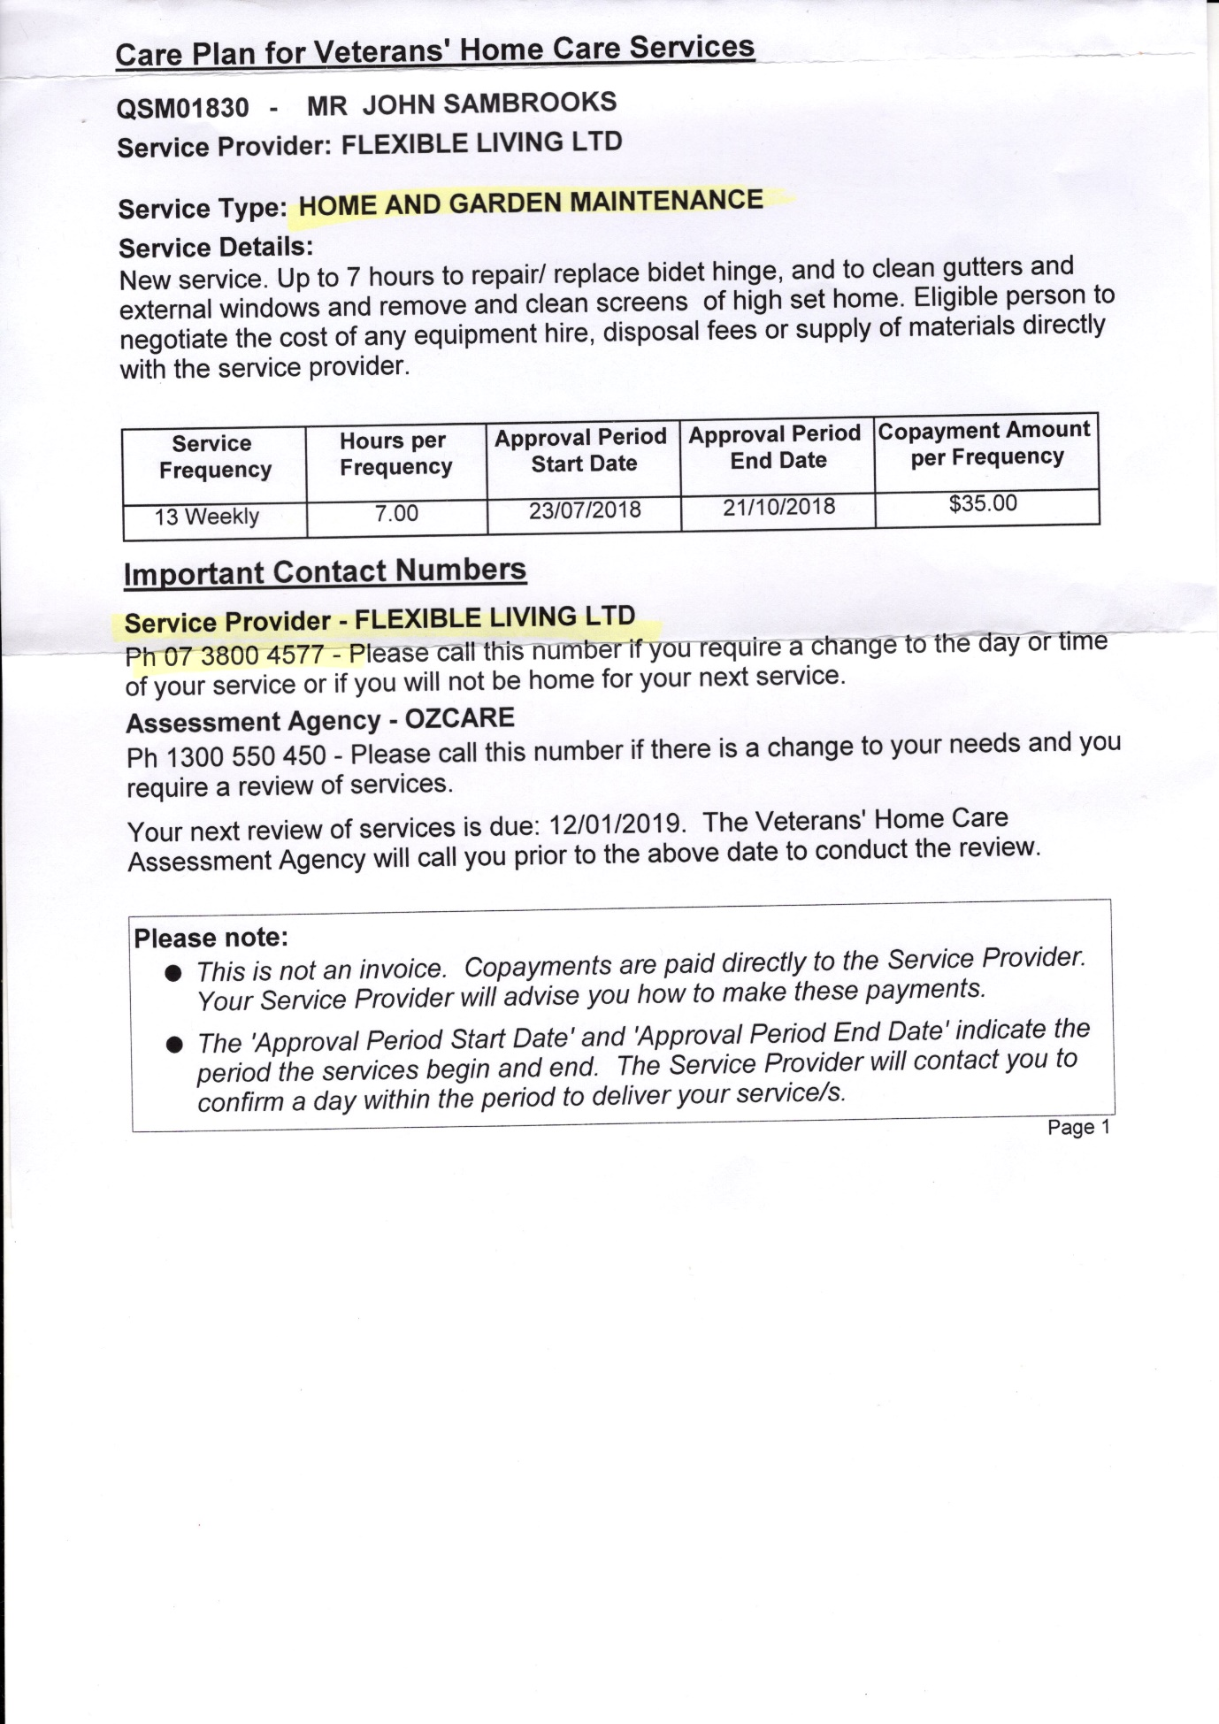
Around Australia Cruise Andrea and I will be cruising around Australia in October 2019. Dan Nebauer is putting a package together and a leaflet will be out in a couple of days re details of this cruise. You will have to be quick if you want to book. These cruises fill quickly.

Taken from Notice Board in the “Vet Affairs” newspaper dated Winter 2018:
A32923 Flight Sergeant Don Derrick The family of the late Don Derrick, a RAAF airframe fitter, is seeking any info about Don’s long service with the RAAF. Problems exist with accessing Don’s service records, so any person who knew him during his various postings both in Aust and overseas, your help would be appreciated. He served with No. 35 Squadron in Vietnam between Aug 1966 and Aug 1967. Contact: Mrs Roylene Conway, 02 6782 1714
I rang Mrs Conway. She told me that Don had never married. If you knew Don, please contact Mrs Conway 02 6782 1714.
WALLABY AIRLINES TIE
I HAVE TWENTY LEFT. THE COST IS $25.00 THAT INCLUDES POSTAGE https://www.dropbox.com/s/eld2sxoldlrjq8y/wallaby%20Tie.png?dl=0
Letter from Len
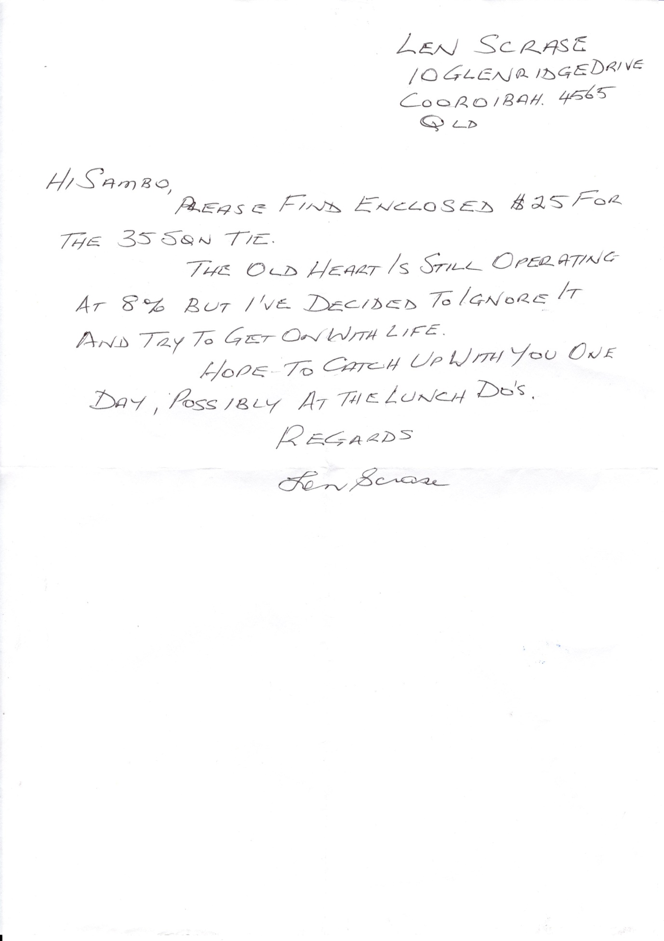

Cheers
Sambo

