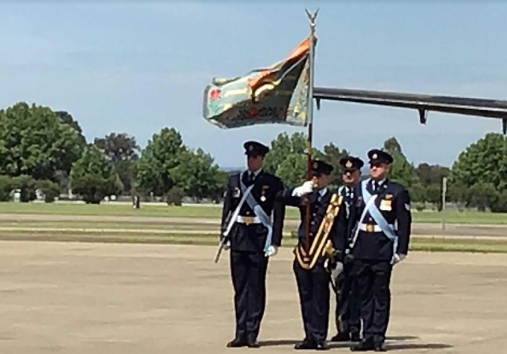
John McDougall and I attended the RAAF Base Richmond on Thursday the first of November, 2018 when the ribbons for the Republic of Vietnam Cross of Gallantry were awarded to 35 Sqn. It was attached to the colours by unscrewing the eagle on top of the rod that holds the Colours, placing the ribbon on the rod then replacing the eagle.

The colour were marched on to the parade which was attended by a number of Wallaby airline members of which I am including photos plus a copy of the governor of New South Wales’ speech

David Pyatt obtained the government speech, many thanks to David and those who were involved.

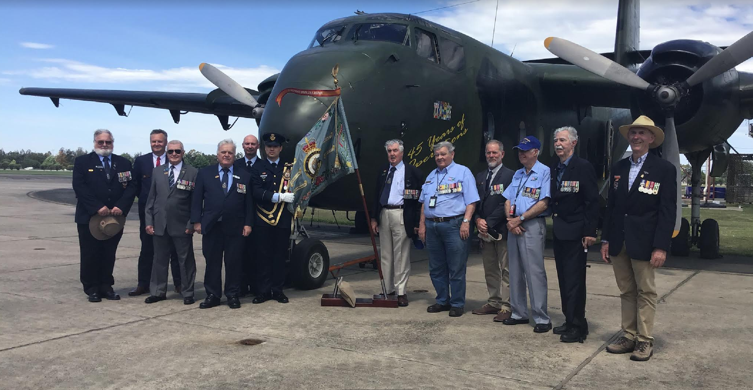

The members who attended were Jock Cassels,Geoff Brand, Shane Scully (Lee’s Son), Ron Glew, John Sambrooks, John McDougall, Bob St John, (don’t remember) Michael Eschback, Fred Romeyn, Richard Jones

John and I flew down with Virgin the day before. When John and I went through security he received the full treatment, Security ended up taking the blade from John’s safety razor and we all know how dangerous the razor blade can be. So John is now known as the slasher.

I said to John every man travelling and staying overnight would carry a razor.

After the parade Ben Poxon, CO 35Sqn, was flying to Brisbane in the Spartan. I asked if we can get on the flight to Brisbane with him. He arranged for John and I to fly back to Brisbane and then arranged a ride to Brisbane airport to pick up John’s car.

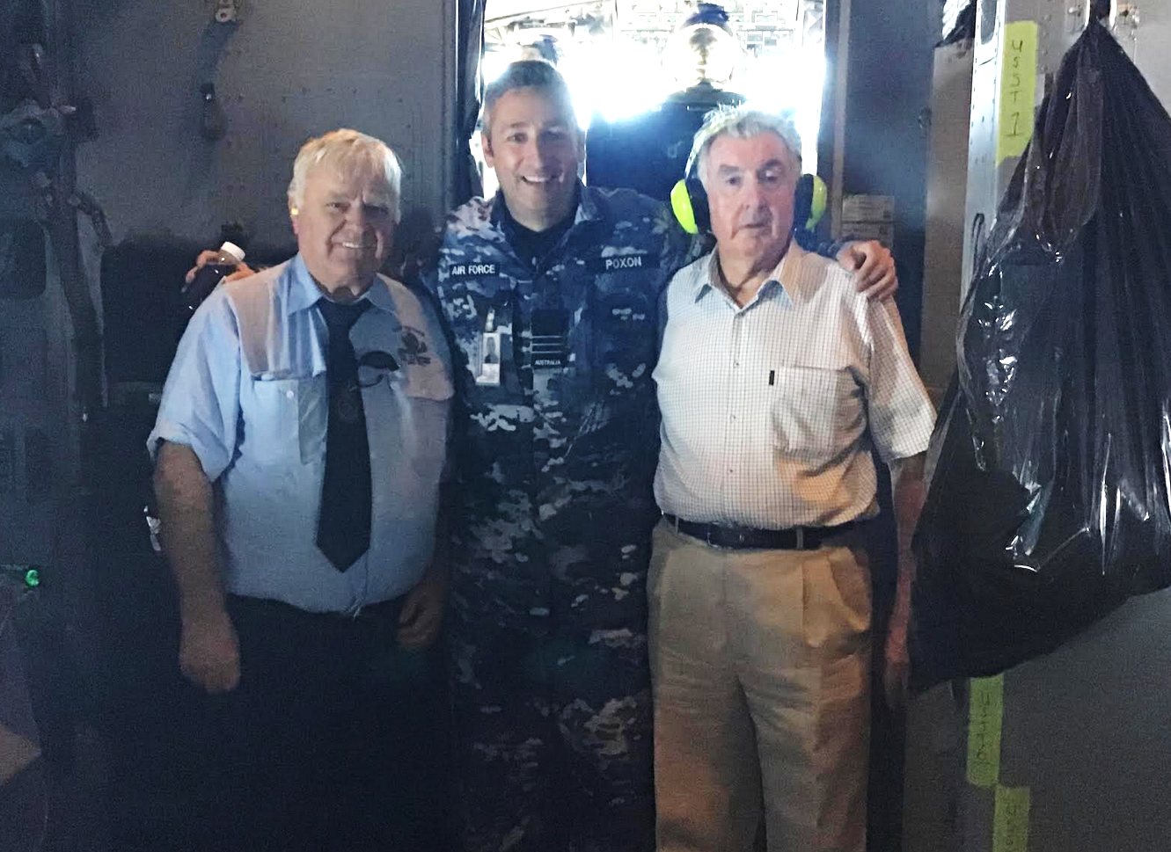

It was our first flight on a Spartan, on take off I was sitting in the jump seat and have a video of the take off. When we landed at Amberley, I thanked Ben and the crew for the flight up to Brisbane.

ANZAC DAY 2019 at the Jade Buddha has been booked and 35 Sqn, which will be based at Amberley by then, will be joining us and if possible, any of our members that can make it, please do to meet the “new boys.” Even if you have regular commitments that day, please try and make it.

It’s really a RAAF Vietnam day, so, no matter in which Sqn you served in Vietnam you are more than welcome. As 9 Sqn has previously joined us, they are most welcome to continue.

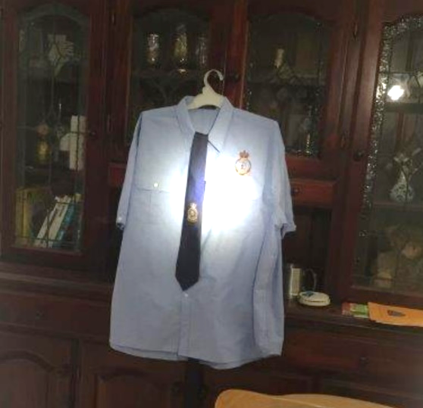
We should have 500 people attending, they tell me the venue will hold up to 700 so there should be plenty room. I will be contacting the Oaks in Felix Street to see what deals they can do for those wishing to stay overnight – details to follow.

WALLABY AIRLINES Shirts and Ties

We have the two logos as an option on the shirt, the tie has the Crest only. The RAAF Vietnam
shirts sell for $55.00 and the Ties $27.50 - that includes postage
Prices for Anzac Day are as follows:
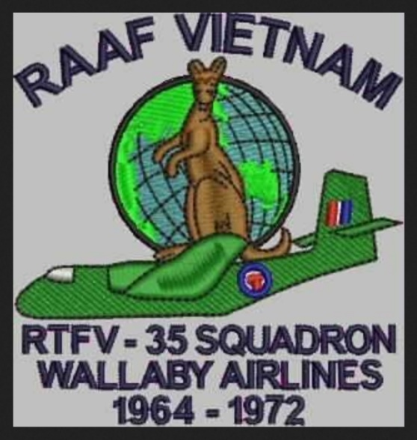
Entrance: $30pp, includes a mixture of canapes and sandwiches
Drinks: discounted prices
$5 XXXX Gold & Hahn Super Dry & Hahn Premium Light (all other at the usual cost)
House Wines $5.00 MudHouse Sauvignon Blanc, Cape Schank Rose, Innocent Bystander Prosecco, Tatachilla Shiraz Cab)
Basic Spirits $8 (Gordons Gin, Bundaberg Rum, Smirnoff Vodka, Johnny Red Scotch, Bacardi, Jim Beam Bourbon)
Soft Drinks $4.50 (Post Mix only) – Sprite, Coke, Diet Coke, Dry, Soda Water, Tonic Water, Lemon Squash

All and any minors must be accompanied by their parent or legal guardian only and have to leave the venue by 8pm.

Wallaby Award

After the Ribbon Parade, I spoke to Ben Poxon about honouring Lee Scully’s efforts in obtaining the Vietnam Gallantry Award in some permanent way – which he was in favour of, and we’ve decided to discuss it further.

One option is to inaugurate a perpetual trophy to be awarded to either a person, or a group, or a section who has displayed and performed beyond expectations. The award would be called the Wallaby Airlines Award.

Your feed back please.

Charity.

John Mac and I were discussing the setting up of a regular annual donation to a charity in Vietnam and now as we have KM Smith as our principal sponsor, this is now possible. We will hold further discussions with interested parties and report in the New Year.

We were thinking of a regular amount from the Association, but you can contribute if you wish.

Your feed back is most welcome.

On behalf of Wallaby Airlines, we’d like to wish everyone a Merry Christmas and a Happy and Jolly New Year.
NSW Govender speech

https://drive.google.com/open?id=1gHfYM4k2xUUjdX342sekmscJ392QFK27

https://drive.google.com/open?id=1gHfYM4k2xUUjdX342sekmscJ392QFK27

