**UNOFFICIAL**

*This material is compiled from sources including the Directorate of History–Air Force, the RAAF Museum, the Australian War Memorial, ADF Serials and Peter Dunn.  The Directorate of History–Air Force is not responsible for pre-1921 items.  Whilst every effort is made to confirm the accuracy of the entries, any discrepancies are solely the responsibility of the originator.*

**20 Jul 43 - 78SQN formed at Camden NSW**

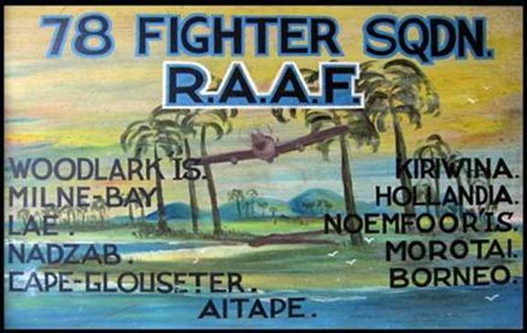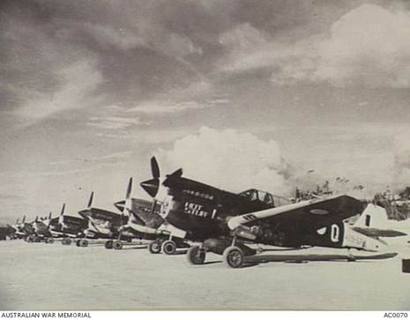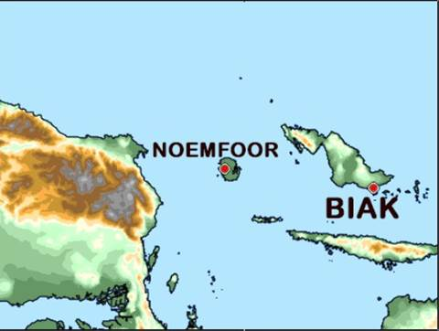

**78SQN Kittyhawk’s, Noemfoor, late 1944**

No 78 Squadron, equipped with Kittyhawk’s, formed at Camden, NSW, on this day.  Operational by October, the unit moved to Kiriwina Island in November, where the squadron provided bomber escort and ground attack missions against targets around Gasmata.  A succession of moves bought the squadron to Hollandia where the unit fought the RAAF's last major air combat of the Pacific War when, on 3 June 1944, sixteen Kittyhawk’s attacked a formation of twelve fighters and three dive-bombers.  For the loss of one aircraft, the Kittyhawk’s claimed nine enemy aircraft destroyed and six damaged.  Subsequent moves took the unit to Noemfoor, Morotai and finally Tarakan where the squadron continued its ground attack operations until the end of the war.  After returning to Australia in December 1945, No 78 Squadron operated Mustangs for a short period until its disbandment in April 1948.

**More here:**   <https://www.awm.gov.au/collection/U59416>  and here:  <https://www.airforce.gov.au/sites/g/files/net3736/f/minisite/static/1469/RAAFmuseum/research/units/78sqn.htm>

**20 Jul 44 - Last air battle fought over Australia**

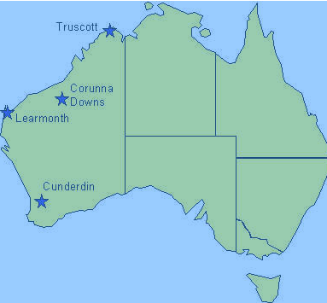  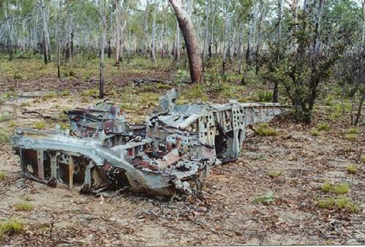  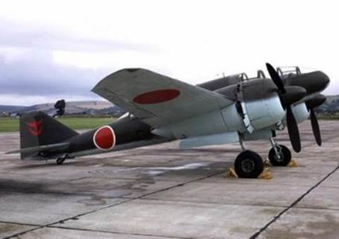    
**Wreckage of Dinah near Truscott                                                                         Mitsubishi Ki-46 *Dinah*reconnaissance aircraft**

In early July 1944, three LF.VIII Spitfires of No 54 Squadron, RAF, on attachment to the RAAF’s North-Western Area, were sent from the Northern Territory to protect a new forward airfield at Truscott, Western Australia.  Early on the morning of this day an enemy aircraft was detected over the Timor Sea by several RAAF radar stations and tracked as it crossed the coast and turned east toward Drysdale and Truscott airfields.   On receiving the alert, the British pilots became airborne at 0850 hours. Two of the Spitfires closed on the bogey, establishing that it was a Mitsubishi Ki 46 Type 100 ‘Dinah’ reconnaissance aircraft.  Both fighters poured fire into the enemy machine, causing the starboard wing to break away. The Dinah burst into flames before falling 9000 metres into the sea eight kilometres north of Drysdale Strip.    This was the last air battle over Australia.

**20 Jul 44 - 1MWS renamed 1ACS**

**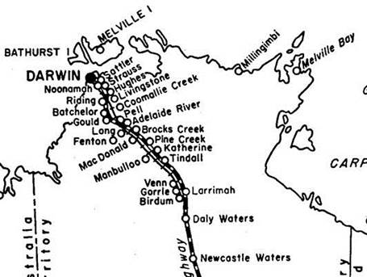  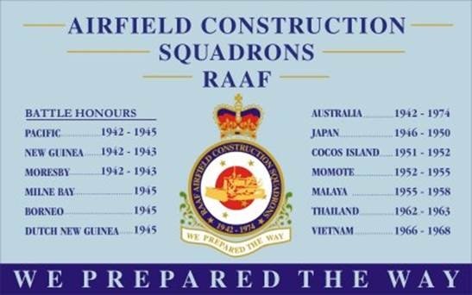**

On 6 April 1942 No 1 Mobile Works Squadron (1MWS) was formed at Ascot Vale, Victoria.  After re-locating to Flemington Racecourse to collect equipment, the unit moved on 19 June by convoy to Pine Creek, NT. The squadron completed the move by the first week in July and began  construction work at Coomalie Creek, Fenton and Hughes airfields.  Moving again to Coomalie Creek in late August 1942, the unit commenced work on airstrips at Fenton, Berrimah, Strauss, Hughes, Livingstone, Millingimbi and Batchelor. In late July 1943, members of 1MWS were posted to form the basis for No 14 MWS.  During August, the remaining personnel were posted south on leave, and the squadron was reformed at Wooloomanata during early October. The unit moved to Ascot Vale in preparation for a return to North-Western Area and continued work on the Fenton and Long airstrips.  During February 1944, the squadron headquarters and the majority of the unit moved to Darwin -- with a detachment being sent to the Anjo Peninsula -- where it was re-named No 1 Airfield Construction Squadron on this day.  The squadron then moved south to Randwick, Sydney, where it assisted with works at Mascot and Marangaroo before deploying to Morotai, arriving on 11 February 1945.  The unit remained there until the end of May 1945 before deploying again to Tarakan where it was disbanded on 30 November 1945.

**20 Jul 64 - RTFV formed at Butterworth**

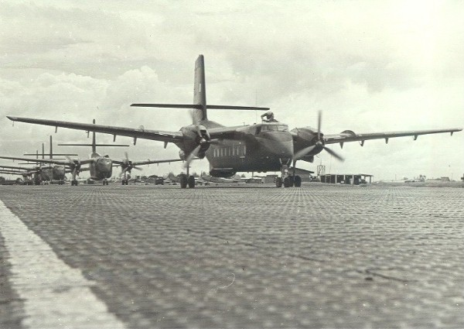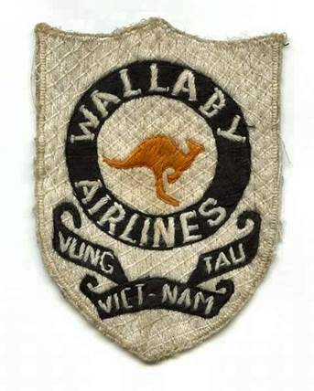

**Five Caribous taxying, Vung Tau, 1967**

Following a 1964 request from the South Vietnamese Government, the Australian Government agreed to deploy an Australian transport unit to South Vietnam.  Officer Commanding RAAF Butterworth was directed to form RAAF Transport Flight Vietnam (RTFV) on this day with the unit to move to Vung Tau, Phuoc Tuy Province, Vietnam, by the end of the month.  The roles of the unit’s six De Havilland Canada Caribou aircraft were troop transport, supply transport, supply dropping, para dropping, communications and medical evacuation with an initial rate of effort for each aircraft of 50 hours per month.  Three aircraft -- A4-171, A4-179 and A4-185 –- arrived at Butterworth and handed over to the RTFV where training was conducted prior to the aircraft deploying to Vietnam on 8 August 1964.  The remaining three aircraft from the fourth delivery flight from Canada (A4-173, A4-191 and A4-193) flew to Vietnam.  RTFV was renamed No 35 Squadron on 1 June 1966.