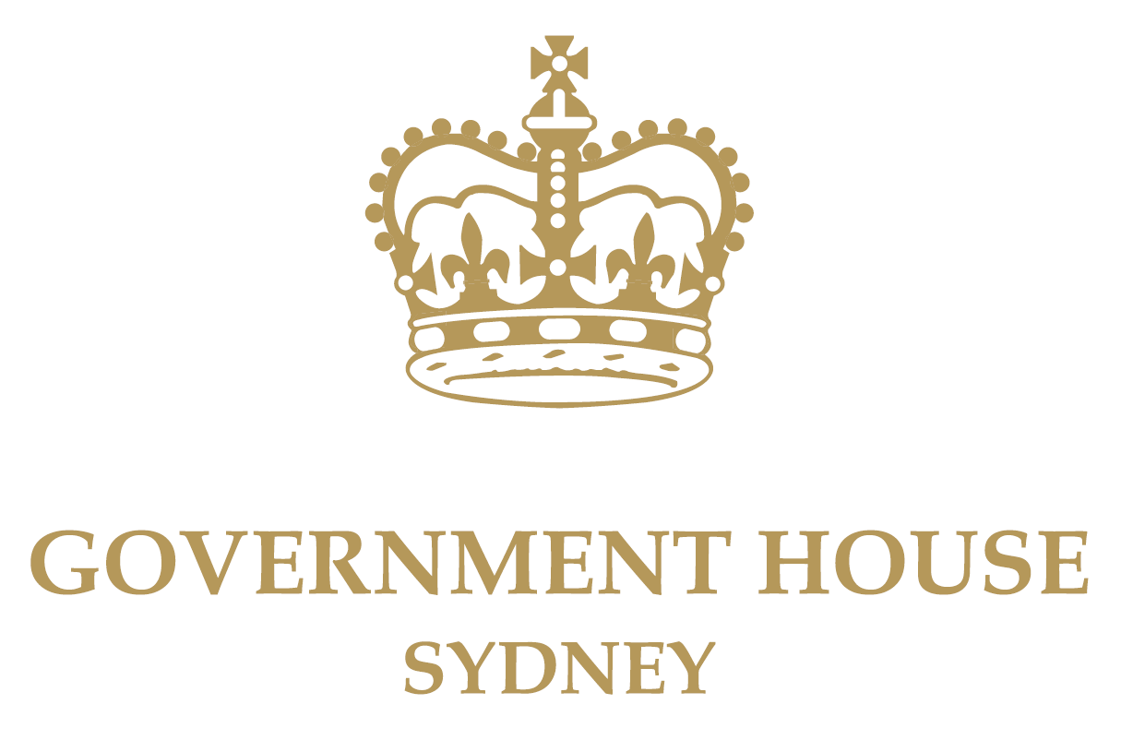

Speaking Points – FINAL

RAAF 35 Squadron
Republic of Vietnam
Cross of Gallantry with Palm Unit Citation
1964-1972 Streamer Parade

Friday, 2nd November, 2018

RAAF Base, Richmond

SPEAKING POINTS

- I would like to commence by conveying my respects to the traditional owners of the land on which we gather, the Darug people, who have sustained and nurtured this land for tens of thousands of years. I acknowledge their living culture and affirm my respect for their Elders, past and present, and all those who have served our nation.

- This is a momentous day for the RAAF and 35 Squadron, a day in which we mark the achievements of the past while also look forward to the future.

- Today marks a significant milestone in the evolution of 35SQN as the Unit has moved from re-establishment in January 2013 to the re-dedication of the Unit Colours in August 2015, a Parade I was privileged to review here at Richmond Base in 2015.

- Today we honour Air Force members who served in Vietnam as part of RAAF Transport Flight Vietnam/35 Squadron from August 1964 to February 1972 under the operational command of United States Military Assistance Command Vietnam.

- In particular, we commend the Squadron on the awarding of the Republic of Vietnam Cross of Gallantry with Palm Unit Citation. The Citation was awarded by the former Government of the Republic of Vietnam (South Vietnam) to specific military units that distinguished themselves in battle. The Governor-General has approved the awarding of the Citation to a number of Australian military units in recognition of their service during the Vietnam War:

- I read from the Australian Defence Force announcement:

Royal Australian Air Force Transport Flight Vietnam/35 Squadron
In May 1964, six of the RAAF new Caribou transport aircraft were sent to Vietnam and it was decided to establish the new unit for Vietnam in Butterworth and the RAAF Transport Flight Vietnam (RTFV) was formed on 21 July 1964.

On 8 August RTFVs first three Caribous arrived at Vung Tau, Vietnam with the Caribous being integrated into the Southeast Asia Airlift System, operated by the United States Air Force (USAF), and became part of the 315th Troop Carrier Group (Assault), which later became the 315th Air Commando Wing. RTFV flew its first operational mission on 14 August.

The unit transported personnel and equipment into some 115 airfields of varying surfaces and dimensions throughout the Republic of Vietnam. The Caribous also carried livestock, mail, fuel drums, and even peasant workers. As the RTFV aircraft used the call-sign Wallaby, the unit quickly became known as ‘Wallaby Airlines’. On 1 June 1966, RTFV was renamed 35 Squadron at Vung Tau in South Vietnam, assigned to the 834th Air Division, of the USAF Seventh Air Force. By June 1971, the Squadrons remaining seven aircraft were reduced to four with the Squadron flying its last operation on 13 February 1972.

- The late Mr John ‘Lee’ Scully (RAAF Vietnam Veterans’ Association President of the Victorian Branch) was the main driving force behind 35 SQN receiving this Citation.

- ‘Lee’ was one of the early members to join the Association. Without Lee’s efforts and determination, the Republic of Vietnam Cross of Gallantry with Palm Unit Citation would not have been achieved at this time. At today’s Parade we acknowledge Lee and his outstanding determination and hard work on behalf of all who served in RTFV-35 Squadron. We are honoured to have Mr Scully’s family in attendance here today.

- 35 Squadron has had a distinguished history in the Australian Defence Force dating from the Second World War when it was formed at RAAF Base Pearce on 11 March 1942, under the command of FLTLT Percival Burdeu, as a transport squadron.
- During the later years of this war, the Squadron provided air transport to the Australian military throughout the South West Pacific area, operating out of Guildford, W.A., and Cape York. In the final years of the war, detachments operated out of Darwin, N.T, Townsville, QLD, and later Moratai Island, Indonesia.

- Following the Japanese surrender in August 1945, No. 35 Squadron flew Australian soldiers and ex-prisoners of war home. In early 1946, it supported the movement of three RAAF fighter Squadrons and various support Units to Japan as part of the British Commonwealth Occupational Force. The Squadron was disbanded at Townsville on the 10 June 1946.
- 18 years later, RAAF Transport Flight Vietnam, the antecedent of what was to become the new 35 SQN, was raised in Butterworth on 21 July 1964 to support the Australian contribution to the war in Vietnam.
- On 8 August, three Caribous took off from Butterworth for Vung Tau, Vietnam. Three more aircraft arrived in late August and a seventh in May 1965. Twelve Caribous would eventually serve in Vietnam.
- The Caribous were integrated into the Southeast Asia Airlift System, operated by the United States Air Force (USAF), and became part of the 315th Troop Carrier Group (Assault), which later became the 315th Air Commando Wing.
- RTFV flew its first operational mission on 14 August.
- The unit transported personnel and equipment into "some 115 airfields of varying surfaces and dimensions" throughout the Republic of Vietnam.
- As the RTFV aircraft used the call-sign "Wallaby", the unit quickly became known as "Wallaby Airlines".
- The unit performed to higher standards than American squadrons with similar aircraft.
- On 1st June 1966 RTFV was renamed 35 Squadron and operational control for the squadron passed to the 834th Air Division of the USAF Seventh Air Force.
- Although the work was routine, flying in a war zone was still dangerous. The weather was often poor and aircraft were hit by enemy ground fire, wounding aircrew.
- Two aircraft were destroyed in landing accidents, while a third was destroyed in March 1970 by mortar fire at That Son air base, near the Cambodian border.
- In June 1971, the Squadron's remaining seven aircraft were reduced to half strength, when three Caribous returned to Australia as part of the Government's decision to decrease Australia's involvement in the war.
- Flying ceased on 13 February 1972. Four Caribous took off six days later and arrived in at Richmond Air Force base on 26 February. 35 SQN was the last RAAF unit to leave Vietnam.
- In its seven and a half years in Vietnam, 35 Squadron flew nearly 80,000 sorties (totalling 47, 000 hours of flying time) and carried 677,000 passengers, 36 million kilos of freight, and 5 million kilos of mail.
- For their involvement in operations in Vietnam, members of the Squadron received a number of honours and decorations, including two appointments to the Member of the Order of British Empire, eight Distinguished Flying Crosses, one Distinguished Flying Medal, one British Empire Medal, and 36 Mention In Dispatches.

- Following the end of our involvement in the Vietnam War, in 1974, No. 35 Squadron was relocated from RAAF Base Richmond to RAAF Base Townsville, where it operated in support of Army units based in Northern Australia.
- The Squadron provided tactical transport to Army units based in Northern Australia until 2000, when it was reduced to "paper only" status and its aircraft transferred to No. 38 Squadron.
- As it had in the past, 35 Squadron would rise again. On 14 January 2013, No. 35 Squadron was re-raised under the command of WGCDR Brad Clarke at RAAF Base Richmond, conducting duties in preparation for the employment of the Alenia C-27J Spartan, Battle Field Airlifter in 2015.
- Earlier this year, in April 2018, the unit received its final delivery to reach its full complement of 10 Alenia C27J Spartan aircraft.
- 35 SQN has recently deployed aircraft and members to assist with Border Protection Commands Operation RESOLUTE. It has participated in various Exercises including PITCH BLACK, HAMEL and CROIX DU SUD (in New Caledonia).
- Also, in March 2018, the unit participated in Exercise Cope North on the island of Guam to test the aircraft’s ability to respond to natural disaster and humanitarian relief operations.
- 35 Squadron is again on the move. The unit is currently preparing to re-locate to purpose built facilities at RAAF Base Amberley in December 2018 to allow the Spartan to be more responsive when deploying across Asia and the Pacific.
- While we in New South Wales are sad to see you go - we know you will continue to support the Blues even while in Maroon territory.
- On behalf of the people of New South Wales, I wish you all the best with this move.
- Thank you for your service to our nation. I am honoured to have the opportunity to present the RSVN Cross of Gallantry 1964-72 Streamer to 35SQN Colours at this Ceremonial Parade.
END

Correct title as now confirmed by 35 Squadron
Refer Background
This information will be mentioned in the Parade Preamble.

