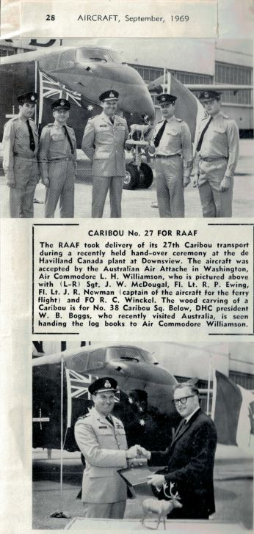
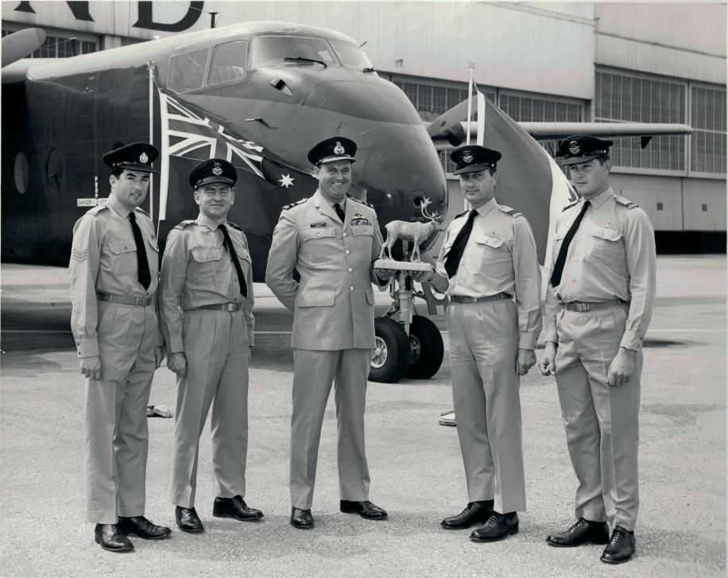
Hi John, information for Wayne re last four Caribou deliveries.
A4-264. Stew Bonett was the Loadmaster / Engineer and they flew the Pacific. Do not recall the other crew members or the exact route.
Check with Stew if he has replied to this request with any details or I will check with him.
A4-275 Crew was Flight Lieutenant Martin Newman, (Captain) Flying Officer Bob Winckel, (Co-pilot) Flight Lieutenant Ron Ewing (Navigator)
Sgt. John McDougall (Loadmaster/ Engineer) We arrived in Toronto Sunday 21 July and did our first test flight 25th July. We departed Downsview
on Friday 2nd August for Ellsworth AFB then to Moffett NAS. From there it was to Hickam AFB, then Johnston Island, Kwajalein, Port Moresby
and finally Richmond, We arrived on schedule 13th August after an uneventful ferry flight - no problems with the aircraft at all.
Post flight de-brief. Recommended no further flights across the Pacific be undertaken! We considered this route to be too dangerous. This is due to the
ferry weight of the aircraft with no alternate airfields in case of emergencies (ie Moffett to Hickam) We were above the normal max take-off weight
of the aircraft for the first eight (8) hours of flight. Not good if you lose an engine halfway!
A4-285 Crew was Wing Commander Kichenside (Captain) Co-pilot? To be advised. Flight lieutenant Ron Ewing (Navigator) Sgt. Allen Fraser
(Loadmaster / Engineer) Flew via the Azores, Europe and Asia. Will check with Al re exact route and advise later. They had a Magneto failure
in the Azores but do not recall any other problems.
A4-299 Captain and Co-pilot to be advised. Sgt. Barry Sharman (Loadmaster / Engineer) Flt. Lt. Ron Ewing (Navigator) Believe ferry route was
the same as 285 but will see if I can find out. Barry is deceased so will have to ring around.
If you need any specific details Wayne, please let me know and I will advise if possible. Take care and keep away from the virus.
All the best for Christmas and the New Year - can only be better than this year.
Regards
John McDougall
Hello John

I was on Caribous when the last a/were delivered but I remember that they started using the Pacific route since on a/c suffered an engine failure & diverted to Johnston Is on single engine. The a/c fuel tanks were supplemented with a bladder tank in the cargo compartment along with extra oil which the Loadmaster had to pump tom 'top up' the engine oil tanks. There must be someone around who could verify or correct me!

I appreciate the great work you are doing giving us all the news in the Caribou world. I still keep in touch with an ex-US Army pilot who has been a great mate since we became friends in SVN in 1966

Cheers Dave

