Update Feb

Possible association day I will be speaking to Scott Egan c/o 35Sqn if it is possible to attend the sqn for an Association day hopefully, he will set a date

I though we could stay overnight at the country motel it is not to far to walk to Brothers Leagues club for dinner I could look at buses to take us to and from Amberley as soon as I have confirmation, I will let everyone know

I have no home phone my contact numbers 0408872736 no change to my email address

John MacDougall email address is [johnmacdougall1944@gmail.com](mailto:johnmacdougall1944@gmail.com)

Wallaby lunches are returning second Thursday each month

Barry Wade

I had a phone call from Barry he is Chummery wade son we spoke for a while I arranged to visit him as he had photo and other papers, letters ETC he is willing to let us put them on our website

John Mac Peter Gleeson and I meet him Monday I have borrowed photo to put on our website

The photo I sent out with Chris Sudgen and Chummery was John Campigli the only time I get emails is when I make mistake thanks to all who replied and feta Dejonge

Some of the photo I received from Barry were off Ray Simpson being Medi Vac

Include are the photos

W/O Ray Simpson Medi Vac Photos chummy Wade Aust War museum

Scroll down

ay Simpson (soldier)

From Wikipedia, the free encyclopedia

[Jump to navigation](https://en.wikipedia.org/wiki/Ray_Simpson_(soldier)#mw-head)[Jump to search](https://en.wikipedia.org/wiki/Ray_Simpson_(soldier)#searchInput)

|  |  |
| --- | --- |
| **Ray Simpson** | |
| Sergeant Rayene Stewart Simpson decorating a Christmas tree in Korea, 1953 | |
| **Birth name** | Rayene Stewart Simpson |
| **Nickname(s)** | "Simmo" |
| **Born** | 16 February 1926 [Redfern](https://en.wikipedia.org/wiki/Redfern,_New_South_Wales), Australia |
| **Died** | 18 October 1978 (aged 52) [Tokyo](https://en.wikipedia.org/wiki/Tokyo), Japan |
| **Allegiance** | Australia |
| **Service/branch** | [Australian Army](https://en.wikipedia.org/wiki/Australian_Army) |
| **Years of service** | 1944–1947 1951–1966 1967–1970 |
| **Rank** | [Warrant Officer Class II](https://en.wikipedia.org/wiki/Warrant_Officer) |
| **Unit** | [Royal Australian Regiment](https://en.wikipedia.org/wiki/Royal_Australian_Regiment) [Special Air Service Company (RAR)](https://en.wikipedia.org/w/index.php?title=Special_Air_Service_Company_(RAR)&action=edit&redlink=1) [1 Commando Company](https://en.wikipedia.org/w/index.php?title=1_Commando_Company&action=edit&redlink=1) [Australian Army Training Team Vietnam](https://en.wikipedia.org/wiki/Australian_Army_Training_Team_Vietnam) |
| **Battles/wars** | Second World War   * [Cowra breakout](https://en.wikipedia.org/wiki/Cowra_breakout) * [South West Pacific theatre](https://en.wikipedia.org/wiki/South_West_Pacific_theatre_of_World_War_II) * [New Guinea campaign](https://en.wikipedia.org/wiki/New_Guinea_campaign)   [Korean War](https://en.wikipedia.org/wiki/Korean_War)   * [Battle of Maryang San](https://en.wikipedia.org/wiki/Battle_of_Maryang_San)   [Malayan Emergency](https://en.wikipedia.org/wiki/Malayan_Emergency) [Vietnam War](https://en.wikipedia.org/wiki/Vietnam_War) |
| **Awards** | [Victoria Cross](https://en.wikipedia.org/wiki/Victoria_Cross) [Distinguished Conduct Medal](https://en.wikipedia.org/wiki/Distinguished_Conduct_Medal) [Silver Star](https://en.wikipedia.org/wiki/Silver_Star) (United States) [Bronze Star](https://en.wikipedia.org/wiki/Bronze_Star_Medal) (United States) |

**Rayene Stewart "Ray" Simpson**, [VC](https://en.wikipedia.org/wiki/Victoria_Cross_for_Australia), [DCM](https://en.wikipedia.org/wiki/Distinguished_Conduct_Medal) (16 February 1926 – 18 October 1978) was an [Australian recipient](https://en.wikipedia.org/wiki/List_of_Australian_Victoria_Cross_recipients) of the [Victoria Cross](https://en.wikipedia.org/wiki/Victoria_Cross), the highest award for gallantry "in the face of the enemy" that can be awarded to members of the British and [Commonwealth](https://en.wikipedia.org/wiki/Commonwealth_of_Nations) armed forces. Simpson received his award for actions in [Kon Tum Province](https://en.wikipedia.org/wiki/Kon_Tum_Province), [South Vietnam](https://en.wikipedia.org/wiki/South_Vietnam) on 6 May 1969.



**Contents**

* [1Early life](https://en.wikipedia.org/wiki/Ray_Simpson_(soldier)#Early_life)
* [2Military career](https://en.wikipedia.org/wiki/Ray_Simpson_(soldier)#Military_career)
  + [2.1Victoria Cross](https://en.wikipedia.org/wiki/Ray_Simpson_(soldier)#Victoria_Cross)
* [3Victoria Cross citation](https://en.wikipedia.org/wiki/Ray_Simpson_(soldier)#Victoria_Cross_citation)
* [4Later life](https://en.wikipedia.org/wiki/Ray_Simpson_(soldier)#Later_life)
* [5Notes](https://en.wikipedia.org/wiki/Ray_Simpson_(soldier)#Notes)
* [6References](https://en.wikipedia.org/wiki/Ray_Simpson_(soldier)#References)
* [7Further reading](https://en.wikipedia.org/wiki/Ray_Simpson_(soldier)#Further_reading)
* [8External links](https://en.wikipedia.org/wiki/Ray_Simpson_(soldier)#External_links)

Early life[[edit](https://en.wikipedia.org/w/index.php?title=Ray_Simpson_(soldier)&action=edit&section=1)]

Rayene Stewart Simpson was born on 16 February 1926 at [Redfern](https://en.wikipedia.org/wiki/Redfern,_New_South_Wales) in Sydney, the third child of New South Wales-born parents Robert William Simpson, labourer, and his wife Olga Maude, née Montgomery. Olga deserted her husband and children about 1931. Ray was separated from his siblings and placed in the Church of England Home for Boys in [Carlingford](https://en.wikipedia.org/wiki/Carlingford,_New_South_Wales). Educated at a local school and at Dumaresq Island Public School, [Taree](https://en.wikipedia.org/wiki/Taree,_New_South_Wales" \o "Taree, New South Wales), he worked as a labourer.[[1]](https://en.wikipedia.org/wiki/Ray_Simpson_(soldier)#cite_note-ADB-1)

Military career[[edit](https://en.wikipedia.org/w/index.php?title=Ray_Simpson_(soldier)&action=edit&section=2)]

Simpson joined the [Second Australian Imperial Force](https://en.wikipedia.org/wiki/Second_Australian_Imperial_Force) on 15 March 1944 and was posted to the [41st/2nd Battalion](https://en.wikipedia.org/w/index.php?title=41st/2nd_Battalion_(Australia)&action=edit&redlink=1), a militia battalion that served as a holding unit for soldiers under 19 years of age. With this battalion, he was posted to [Cowra](https://en.wikipedia.org/wiki/Cowra,_New_South_Wales" \o "Cowra, New South Wales) as part of the prisoner of war camp garrison which had been reinforced after the [Cowra breakout](https://en.wikipedia.org/wiki/Cowra_breakout" \o "Cowra breakout) on 5 August 1944. He was subsequently posted to the [2/3rd Pioneer Battalion](https://en.wikipedia.org/wiki/2/3rd_Pioneer_Battalion_(Australia)), while subsequent postings included the Advanced Ordnance Depot and the [26th Battalion](https://en.wikipedia.org/wiki/26th_Battalion_(Australia)).[[2]](https://en.wikipedia.org/wiki/Ray_Simpson_(soldier)#cite_note-FOOTNOTEWigmore1986175-2) During this time he served in Morotai, Tarakan and Rabaul.[[1]](https://en.wikipedia.org/wiki/Ray_Simpson_(soldier)#cite_note-ADB-1)

Demobilized in January 1947, Simpson spent four years working in various jobs in Australia and Papua New Guinea, before re-enlisting in the Army in 1951 to serve in the [Korean War](https://en.wikipedia.org/wiki/Korean_War) with the [3rd Battalion, Royal Australian Regiment](https://en.wikipedia.org/wiki/3rd_Battalion,_Royal_Australian_Regiment). He was promoted to [lance corporal](https://en.wikipedia.org/wiki/Lance_corporal) on 30 November 1951 and again to [corporal](https://en.wikipedia.org/wiki/Corporal) on 21 January 1953. He married Shoko Sakai, a Japanese citizen, on 5 March 1952.[[2]](https://en.wikipedia.org/wiki/Ray_Simpson_(soldier)#cite_note-FOOTNOTEWigmore1986175-2)

Simpson was posted to the [2nd Battalion, Royal Australian Regiment](https://en.wikipedia.org/wiki/2nd_Battalion,_Royal_Australian_Regiment) in January 1954, where he was promoted to [sergeant](https://en.wikipedia.org/wiki/Sergeant) in 1955, serving in [Malaya](https://en.wikipedia.org/wiki/Malayan_Emergency) from October 1955 for the next two years. He was subsequently posted to [1st Special Air Service Company](https://en.wikipedia.org/wiki/Special_Air_Service_Regiment) (SAS) in November 1957 and served with that unit until selected as one of the initial group members of the [Australian Army Training Team Vietnam](https://en.wikipedia.org/wiki/Australian_Army_Training_Team_Vietnam) (AATTV) sent to assist South Vietnamese forces in July 1962. A year later, he returned to the SAS in Australia and served there for the next twelve months.[[3]](https://en.wikipedia.org/wiki/Ray_Simpson_(soldier)#cite_note-FOOTNOTEWigmore1986175%E2%80%93176-3)

His second tour of duty with AATTV in Vietnam commenced in July 1964, after being promoted to [warrant officer class II](https://en.wikipedia.org/wiki/Warrant_Officer). During his second tour, he was awarded the [Distinguished Conduct Medal](https://en.wikipedia.org/wiki/Distinguished_Conduct_Medal) for his actions when a patrol was ambushed at Tako on 16 September. Simpson, although severely wounded in the leg, held off the enemy while he called for assistance by radio. He and his men repelled several enemy assaults until help arrived, and none too soon as their ammunition was almost gone and Simpson was weak from loss of blood. He was evacuated by helicopter to the 6th Field Hospital at [Nha Trang](https://en.wikipedia.org/wiki/Nha_Trang" \o "Nha Trang) and later convalesced in [Tokyo](https://en.wikipedia.org/wiki/Tokyo).[[4]](https://en.wikipedia.org/wiki/Ray_Simpson_(soldier)#cite_note-FOOTNOTEWigmore1986176-4) On return to Australia, he was posted to the [1st Battalion, Royal New South Wales Regiment (Commando)](https://en.wikipedia.org/wiki/1st_Battalion_(Australia)) in Sydney in January 1966.[[1]](https://en.wikipedia.org/wiki/Ray_Simpson_(soldier)#cite_note-ADB-1)

On 16 May 1966, Simpson left the army for a second time, but re-enlisted in [Saigon](https://en.wikipedia.org/wiki/Saigon) a year later for his third period of service with the AATTV, during which he was awarded the Victoria Cross.[[4]](https://en.wikipedia.org/wiki/Ray_Simpson_(soldier)#cite_note-FOOTNOTEWigmore1986176-4) He also received the United States [Silver Star](https://en.wikipedia.org/wiki/Silver_Star) and [Bronze Star](https://en.wikipedia.org/wiki/Bronze_Star_Medal) for his actions in Vietnam.[[5]](https://en.wikipedia.org/wiki/Ray_Simpson_(soldier)#cite_note-FOOTNOTEWigmore1986177-5)

**Victoria Cross**[[edit](https://en.wikipedia.org/w/index.php?title=Ray_Simpson_(soldier)&action=edit&section=3)]

Simpson was 43 years old, and a warrant officer class II in the Australian Army Training Team, when he was awarded the Victoria Cross. On 6 May 1969, in [Kon Tum Province](https://en.wikipedia.org/wiki/Kon_Tum_Province), Simpson rescued a wounded fellow warrant officer and carried out an unsuccessful attack on a strong enemy position. On 11 May he fought alone against heavy odds to cover the evacuation of a number of casualties.[[6]](https://en.wikipedia.org/wiki/Ray_Simpson_(soldier)#cite_note-6)[[7]](https://en.wikipedia.org/wiki/Ray_Simpson_(soldier)#cite_note-FOOTNOTEWigmore1986176%E2%80%93177-7) Simpson was presented his Victoria Cross from Queen [Elizabeth II](https://en.wikipedia.org/wiki/Elizabeth_II), at Government House in Sydney on 1 May 1970.

Victoria Cross citation[[edit](https://en.wikipedia.org/w/index.php?title=Ray_Simpson_(soldier)&action=edit&section=4)]

The citation in the [Commonwealth of Australia Gazette](https://en.wikipedia.org/wiki/Commonwealth_of_Australia_Gazette) of 28 August 1969, which announced Simpson's award reads:

Government House,

Canberra, ACT 2600

21 August 1969

HER Majesty The Queen has been graciously pleased to bestow the award of the Victoria Cross upon the following member of the Royal Australian Infantry Corps For most conspicuous bravery.

VICTORIA CROSS

Warrant Officer, Class 2, Rayene Stewart Simpson, DCM Warrant Officer Simpson enlisted initially in 1944 He has seen active service in the Pacific, Korea, Malaysia and Vietnam where he is now serving his third tour.

On 6 May 1969, Warrant Office Simpson was serving as Commander of 232nd Mobile Strike Force Company of 5th Special Forces Group on a search and clear operation in Kontum Province, near the Laotion border. When one of his platoons became heavily engaged with the enemy, he led the remainder of his company to its assistance. Disregarding the dangers involved, he placed himself at the front of his troops, thus becoming a focal point of enemy fire, and personally led the assault on the left flank of the enemy position. As the company moved forward, an Australian warrant officer commanding one of the platoons was seriously wounded and the assault began to falter. Warrant Officer Simpson, at great personal risk and under heavy enemy fire, moved across open ground, reached the wounded warrant officer and carried him to a position of safety. He then returned to his company where, with complete disregard for his safety, he crawled forward to within ten metres of the enemy and threw grenades into their positions. As darkness fell, and being unable to break into the enemy position, Warrant Officer Simpson ordered his company to withdraw. He then threw smoke grenades and, carrying a wounded platoon leader, covered the withdrawal of the company together with five indigenous soldiers. His leadership and personal bravery in this action were outstanding.

On 11th May 1969, in the same operation, Warrant Officer Simpson's battalion commander was killed and an Australian Warrant Officer and several indigenous soldiers were wounded. In addition, one other Australian Warrant Officer who had been separated from the majority of his troops was contained in the area by enemy fire. Warrant Officer Simpson quickly organised two platoons of indigenous soldiers and several advisors and led them to the position of the contact On reaching the position the element with Warrant Officer Simpson came under heavy fire and all but a few of the soldiers with him fell back Disregarding his own safety he moved forward in the face of accurate enemy machine gun fire, in order to cover the initial evacuation of the casualties. The wounded were eventually moved out of the line of enemy fire, which all this time was directed at Warrant Officer Simpson from close range. At the risk of almost certain death he made several attempts to move further forward towards his Battalion Commander's body but on each occasion he was stopped by heavy fire. Realising the position was becoming untenable and that priority should be given to extricating other casualties as quickly as possible, Warrant Officer Simpson alone and still under enemy fire covered the withdrawal of the wounded by personally placing himself between the wounded and the enemy From this position he fought on and by outstanding courage and valour was able to prevent the enemy advance until the wounded were removed from the immediate vicinity Warrant Officer Simpson's gallant and individual action and his coolness under fire were exceptional and were instrumental in achieving the successful evacuation of the wounded to the helicopter evacuation pad.

Warrant Officer Simpson's repeated acts of personal bravery in this operation were an inspiration to all Vietnamese, United States and Australian soldiers who served with him His conspicuous gallantry was in the highest tradition of the Australian Army

[[8]](https://en.wikipedia.org/wiki/Ray_Simpson_(soldier)#cite_note-8)

Hi Sambo  
Should be an interesting read  
Regards  
Kev

# [The Canberra Times](https://www.canberratimes.com.au/)

**REVIEW**

JANUARY 30 2021 - 12:00AM

The Long Shadow, Peter Yule's account of Australia's Vietnam veterans in the years since the war, is important and impressive

* **Michael McKernan**

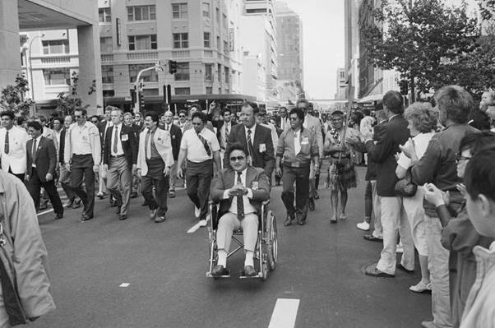

A scene from the Welcome Home Parade in 1987 at the Domain. Picture: Australian War Memorial

**The Long Shadow: Australia's Vietnam Veterans Since The War, by Peter Yule. Australian War Memorial and NewSouth, $49.99.**

This book is as important as it is impressive. It is a long book, 568 pages of text. In his foreword, General Sir Peter Cosgrove says he read it in a sitting. Wow! The General obviously has more stamina than most. But if he means it is hard, almost impossible, to put down, then most readers would agree.

It is remarkable - even astonishing - that the book is published by the Australian War Memorial, usually a cautious and careful publisher. You won't die wondering what Peter Yule thinks. He lines up his targets and disposes of them carefully and with forensic intensity.

The targets are numerous and include: American and Australian strategy in Vietnam, Australian prime ministers and politicians who sent our soldiers to war and kept them there, the Department of Veterans' Affairs, deceitful and cowardly, most of its ministers and secretaries, the Evatt Royal Commission into Agent Orange, the official historian of Agent Orange, Professor F.B. ('Barry') Smith and, by implication, the supervising official historian who commissioned and published Smith, Dr Peter Edwards.

*The Long Shadow* is firmly on the side of Vietnam veterans and their families, and it abounds with their voices. The veterans were sometimes wrong. There was no riot at Sydney airport between returning veterans and anti-war protestors. No Australian ever threw red paint over marching Australian returning veterans. There was no booing and little protest at the marches in capital cities to celebrate the return of units.

But mostly the veterans were right. It was the wrong war and it couldn't be won. They were grievously damaged by the war they fought. They were hounded and hurt by the way Australians viewed their war and by their perceived place in Australian society. They were good, perhaps great, soldiers, well-trained, cohesive, resilient, efficient, hard-working and reliant on one another.

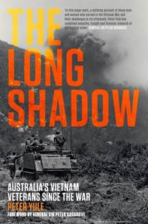

But it is a sad book. There is misery, suffering, outrage and injury on almost every page. Yet there are moments of great happiness and joy - the Welcome Home parade in Sydney in 1987, the eventual understanding and broadly-based support of the Australian community, and the support and comfort that veterans fostered among themselves.

This is, fundamentally, a medical history and that is why it is so important. It examines physical and psychological injury at war, it accounts for the emerging term and condition, post-traumatic stress disorder, and it shows how careful medical attention and counselling can - eventually - heal.

The book came about in response to veterans' outrage at the publication of a volume of the official history, Medicine at War, and Barry Smith's essay on Agent Orange in that book. Yule concludes - trenchantly - that Smith "did not so much write a history as present a case, making personal attacks, distorting evidence, and gloating over the discomfiture of veterans". "[The veterans]," writes Yule, "deserved better of an official history." They have it in The Long Shadow.

One of the strengths of the book is to show the interconnections between the American experience of Vietnam and the Australian experience. Yule makes the excellent point that the cohesion and comradeship of Australian units was fostered by the fact that most soldiers arrived in Vietnam as part of a unit or battalion. They had trained together to peak efficiency in Australia, they had travelled together, and they fought together. In contrast the Americans arrived in Vietnam individually and were assigned to a unit after their arrival.

But the aftermath of the war in both countries was very similar with a close liaison on so many matters affecting the veterans' welfare, health and wide-ranging medical research. It was American research and integrity that helped overturn the effects of the Evatt Royal Commission in Australia.

Readers will be amazed and warmed by the lengthy account of the persistence of key Australian veterans and organisations in confronting governments, seeking to improve the health and welfare of their mates. Men like Phill Thompson, Tim McCombe and Graham Walker deserve recognition and honour for their unpaid, voluntary and skilled campaigning on behalf of their mates.

Yule makes no distinction between the service in Vietnam of national servicemen and regular soldiers. But he makes the essential point that there was a great deal of difference in their rehabilitation in Australia. A national serviceman, fighting in the jungle one day, might be back at work in bank or office a couple of days later. Mates on whom they had relied for life itself were lost to them. Read this wonderful book. It will open your eyes to a tragedy in the Australian story.▄

**********

Dr Michael McKernan is an author, editor, and historian. He has worked as an academic, public servant, and consultant. His experience includes being a former broadcaster for the Australian Broadcasting Company and a deputy director of the Australian War Memorial in Canberra. Amongst the many books he has authored is *When This Thing Happened*, an account of one veteran's tragedy in Vietnam.

l Secretary

**From:** Mark Barnes <[mbarnesau@gmail.com](mailto:mbarnesau@gmail.com)>   
**Sent:** Thursday, 21 January 2021 3:25 PM  
**To:** [secretary@vvaa.org.au](mailto:secretary@vvaa.org.au)  
**Subject:** Information on Vietnam veterans not on nominal rolls

Hi Terry,

I hope this finds you safe and well.

My name is Mark. I am a journalist based in Hanoi. I have been working on a story about a man named Peter Caughley who died in Cambodia in 2018. Several people have told me that he was a Vietnam veteran, however, I've been unable to confirm this. He was a Kiwi but lived in Australia so I've checked both the Australian and NZ rolls. I've also trawled the internet but have found nothing. Is there any other way I might be able to find more information? Is there perhaps a Facebook group that I could ask?

The story is about his life in Hanoi back in 2011 and during that time it appears he was a bit of a mystery. No one here knows much about his life before he arrived. I know this is a stretch but if you have any suggestions about where I could look next I would really appreciate it.

Thanks in advance,

Mark Barnes

[mbarnesau@gmail.com](mailto:mbarnesau@gmail.com)

Hanoi, Vietnam

Phone:+84886889402

Signal: +84886889402

Whatsapp: [+61411964058](https://api.whatsapp.com/send?phone=+61411964058)

Portfolio: [w](https://muckrack.com/mbarnesau)[ww.markbarnes.com.au](http://ww.markbarnes.com.au)

Photo in Toronto Nov 1963 can you help with Names

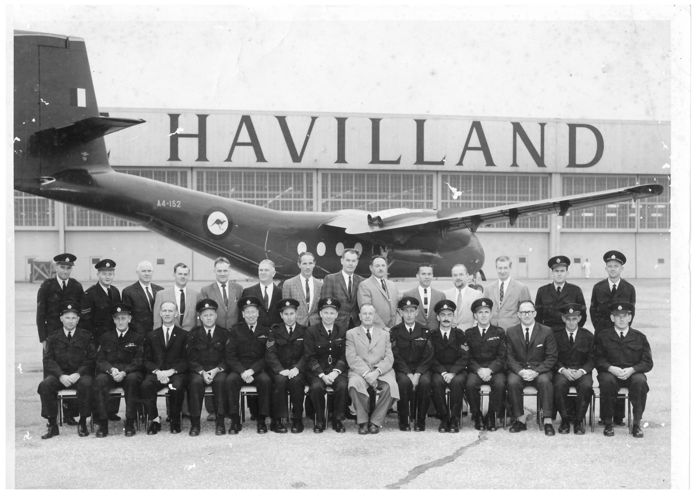

|  |  |
| --- | --- |
|  |  |
|  |  |
|  |  |
|  |  |

Hi John,

As mentioned at the phsio's this morning the reply from Ben in DVA.

Greg Russell

On 2/02/2021 4:10 pm, Isaacs, Ben wrote:

Hi Greg

Sorry for the delay – please see below information:

1. The Department of Veterans’ Affairs (DVA) is not reducing services delivered from the Veterans’ Affairs Phone Authorities Centre (VAPAC) managed by DVA.
2. There will be no reductions in current service delivery standards for health providers utilising VAPAC service to treat their veteran patients.
3. Some changes are planned to workforce arrangements from 1 April 2021, with DVA engaging individuals with pharmacy assistant qualifications to undertake prior approvals via the Repatriation Pharmaceutical Benefits Scheme (RPBS).
4. This change follows a recent review of VAPAC and ensures all calls are managed by a workforce with correlating qualifications and experience.
5. The VAPAC service will continue as business as usual:
   1. The 24/7 (1800 552 580) phone line will remain in full operation out of the DVA Brisbane office.  The pharmacy assistants will not be engaged via Bupa.
   2. Pharmacy assistants will be supported by qualified and registered pharmacists, who will continue to provide advice for complex pharmaceutical matters.  All matters that require the involvement of a pharmacist will continue to be handled by a pharmacist.
   3. There are no changes to funding access for pharmaceuticals.
6. There are no changes to the RPBS.  The RPBS continues to offer an extensive range of medications and wound care items to eligible veterans, their dependents and widow/ers.
7. Veterans should continue to visit their treating doctor in accordance with their treatment plan and to access their pharmaceutical scripts.
8. A recent VAPAC review identified that 88 per cent of VAPAC approved prescriptions related to items listed under the PBS which have strict guidelines for funding approval.  They are considered simple approvals using a guided workflow and do not require the expertise of a qualified pharmacist.  From 1 April 2021, the remaining 12 per cent will be escalated to a registered pharmacist within DVA.

**How will this impact veterans and their families?**

1. There will be no adverse impacts to the services provided by DVA to health professionals treating their veteran patients. Access to the VAPAC 1800 552 580 phone line will remain a 24/7 service.

**Will veterans be able to access their medications?**

1. Yes, there are no changes to medication access.  Veterans should continue their health treatment through their treating doctor in order to access pharmaceutical scripts.

**Will there be restrictions on pharmaceuticals for mental health?**

1. No, this is an operational change and there will be no changes to medication access for veterans.  Pharmaceutical scripts for mental health medication should continue to be accessed through a veteran’s treating doctor.
2. *If you or someone you know needs support, the team at Open Arms - Veterans & Families Counselling, provides free and confidential counselling 24 hours a day, 7 days a week on 1800 011 046.*

**Will there be changes to the co-payment?**

1. No, the co-payment remains $6.60.

**Will there be changes to the Safety Net Threshold?**

1. No, the safety net threshold remains at 48 scripts or $316.80.  Once a veteran has paid the co-payment of $6.60 for 48 scripts, the co-payment will no longer be required for the remaining calendar period.

Kind Regards

Ben Isaacs

Assistant Director

Pharmacy Programs and Operations | Client Programs Branch

Client Engagement and Support Services Division

Department of Veterans' Affairs

**t** 07 3223 8714 **ext**470714 **m** 0406 381 916

**From:** Greg & Pam Russell <pamgreg@bigpond.net.au>   
**Sent:** Wednesday, 3 February 2021 6:20 PM  
**To:** wallabysam14@gmail.com  
**Subject:** Fwd: PHARMACISTS AT DVA HOTLINE SERVICE -1800 520 580 MUST STAY.. [TO BE CLASSIFIED] [SEC=OFFICIAL]

|  |  |
| --- | --- |
|  |  |
|  |  |
|  |  |
|  |  |

Hi John,

As mentioned at the phsio's this morning the reply from Ben in DVA.

Greg Russell

On 2/02/2021 4:10 pm, Isaacs, Ben wrote:

Hi Greg

Sorry for the delay – please see below information:

1. The Department of Veterans’ Affairs (DVA) is not reducing services delivered from the Veterans’ Affairs Phone Authorities Centre (VAPAC) managed by DVA.
2. There will be no reductions in current service delivery standards for health providers utilising VAPAC service to treat their veteran patients.
3. Some changes are planned to workforce arrangements from 1 April 2021, with DVA engaging individuals with pharmacy assistant qualifications to undertake prior approvals via the Repatriation Pharmaceutical Benefits Scheme (RPBS).
4. This change follows a recent review of VAPAC and ensures all calls are managed by a workforce with correlating qualifications and experience.
5. The VAPAC service will continue as business as usual:
   1. The 24/7 (1800 552 580) phone line will remain in full operation out of the DVA Brisbane office.  The pharmacy assistants will not be engaged via Bupa.
   2. Pharmacy assistants will be supported by qualified and registered pharmacists, who will continue to provide advice for complex pharmaceutical matters.  All matters that require the involvement of a pharmacist will continue to be handled by a pharmacist.
   3. There are no changes to funding access for pharmaceuticals.
6. There are no changes to the RPBS.  The RPBS continues to offer an extensive range of medications and wound care items to eligible veterans, their dependents and widow/ers.
7. Veterans should continue to visit their treating doctor in accordance with their treatment plan and to access their pharmaceutical scripts.
8. A recent VAPAC review identified that 88 per cent of VAPAC approved prescriptions related to items listed under the PBS which have strict guidelines for funding approval.  They are considered simple approvals using a guided workflow and do not require the expertise of a qualified pharmacist.  From 1 April 2021, the remaining 12 per cent will be escalated to a registered pharmacist within DVA.

**How will this impact veterans and their families?**

1. There will be no adverse impacts to the services provided by DVA to health professionals treating their veteran patients. Access to the VAPAC 1800 552 580 phone line will remain a 24/7 service.

**Will veterans be able to access their medications?**

1. Yes, there are no changes to medication access.  Veterans should continue their health treatment through their treating doctor in order to access pharmaceutical scripts.

**Will there be restrictions on pharmaceuticals for mental health?**

1. No, this is an operational change and there will be no changes to medication access for veterans.  Pharmaceutical scripts for mental health medication should continue to be accessed through a veteran’s treating doctor.
2. *If you or someone you know needs support, the team at Open Arms - Veterans & Families Counselling, provides free and confidential counselling 24 hours a day, 7 days a week on 1800 011 046.*

**Will there be changes to the co-payment?**

1. No, the co-payment remains $6.60.

**Will there be changes to the Safety Net Threshold?**

1. No, the safety net threshold remains at 48 scripts or $316.80.  Once a veteran has paid the co-payment of $6.60 for 48 scripts, the co-payment will no longer be required for the remaining calendar period.

Kind Regards

Ben Isaacs

Assistant Director

Pharmacy Programs and Operations | Client Programs Branch

Client Engagement and Support Services Division

Department of Veterans' Affairs

**t** 07 3223 8714 **ext**470714 **m** 0406 381 916