35Sqn Birthday celebration Amberley 11/03/21
Attendee were John McDougall John Griffiths me Trevor Benneworth Peter Gleeson Andrea Butler Jennie McIntosh. 35 Sqn made sure it was a great day they had A4 236 on the flight line towing from the museum C/o Scott Egan spoke about 35sqn history and presented some awards
There were several speakers including a speech from an American air man
35 SQN. Birthday.

Back on the 2rh February 1942 at RAAF Base Pearce a young LAC Alfred Boyd and another LAC were told to report to Flying Officer Giles. He informed them that the three of them were now members of a new unit known as 35 Sqn. The unit was soon allocated a De Haviland Fox Moth aircraft and an ex-Air Ambulance De Haviland Dragon Rapide and this allowed the Squadron to commence operations on 11 March 1942. The squadron initially operated a motley collection of aircraft mostly unsuitable for transport operations. They flew mostly within Western Australia but as they acquired more aircraft they began to operate through Australia. In December 1943 they received the DC3 Dakota and were then able to operate as a transport unit in PNG and South West Pacific area. Post war the squadron helped repatriate PoWs back to Australia before being disbanded on 19 June 1946. The squadron made a considerable contribution to transport operations and the war effort during its four years of service.
We now move forward to July 1964. The third flight of three new Caribou aircraft were on route from Toronto to Richmond. When they arrived at Butterworth, they were told not to proceed to Darwin but to turn left and fly to Viet Nam. They were now going to war. They arrived in Saigon on the 8th August and became the RAAF Transport Flight Viet Nam. This small detachment became the nucleus for the reformation of No. 35 Sqn. on the 1st June 1966.
History was now repeating itself. In 1942 the squadron had three personnel and no aircraft initially and now in Viet Nam we had three aircraft with crews but no ground staff, facilities or equipment. We started operating within days of arriving in country and with very little Caribou knowledge or experience it was a steep learning curve for all concerned.
The common theme between the events of 1942 and 1964 is the squadron personnel. In both cases both air and ground crews fully co-operated and respected each other for the common good of the unit. Through difficult and hazardous Conditions, we all worked tirelessly to maintain the aircraft serviceability rate and to operate the aircraft at its maximum utilization.
I do not have any figures for WW11but I do know what 35 Squadron achieved in Viet Nam. In seven and a half years with six, sometimes seven, aircraft we flew 81,000 sorties totalling 44,000 flying hours, carried 680,000 passengers and 46 million kilos of freight. 35 Squadron consistently outperformed any other transport unit in country, flying only 1.4 percent of transport missions but
served with the squadron. Because of these impressive statistics 35 Squadron was awarded the Republic of Viet Nam Cross of Gallantry with Palm Unit Citation which current squadron members now wear.
After 35 Squadron returned to Australia its efficiency and effectiveness did not decrease. Because of the unit's high standard of proficiency, it was awarded the Duke of Gloucester Cup in October 1976 and again in August 1983. Also, at this time 35Squadron became the only RAAF unit to operate both fixed and rotary wing aircraft at the one time
As you can see, 35 Squadron has achieved a long and proud history of service to the ADF and Australia in general. This has covered war service, civil aid and disaster relief both here and overseas. You people are now part of that history. It is a proud history of innovation and determination to excel.
I am confident that the present members of 35 Squadron are as dedicated and enthusiastic as the previous members of the unit have demonstrated and will continue to uphold the proud tradition of 35Squadron into the future.

Thank you and Happy 791t1 Birthday 35 Squadron. May we celebrate many more birthdays together. Look forward to seeing you all at the Jade Buddha on ANZAC Day.

lick on link for photos right click then click open hyper linkhttps://1drv.ms/u/s!AnOMjxMP-5eng6NH_rGsz0tHRlU3kw?e=LRWdid

A big thank you to K M SMITH for their sponsorship as it helps keep our assn. financial. Without their support it would be difficult to maintain our website. We were the first to receive a grant to set up our website and all the infrastructure that goes with PayPal etc. (Beetle)Bailey also attended. Beetle was 35sqn’s first Warrant Officer. It was great to see Beetle. There has been a total of four W.O. since 35 has been reformed Ralph Clifton, Des Brennan now Evan Cannard. We have been lucky they have assisted with any request we may have had and are members of Wallaby Airlines. It was a great day. Anzac Day we don’t have to register but if you are attending please shoot me an email so we can have a record of who attends each year.
35 Sqn will have 100 troops marching and will attend the Jade Buddha with us. Schooner prices will be $5.00 as will wines. Your function is now confirmed for the following details;
Date: Anzac Day 2021 (Sunday, 25th April)
Location: Jade Buddha Level Exclusive Hire
Timing: 10am until 4pm
Guests: 500+

Food: $29pp, a mixture of canapes and sandwiches (Jade Buddha Staff to collect on the door)
Drinks: discounted prices (I have been able to match last years discounts for this year, but that will probably have to increase next year)
– $5 XXXX Gold & Hahn Super Dry & Hahn Premium Light (all other at the usual cost)
- $5 House Wines (MudHouse Sauvignon Blanc, Days of Rose, Innocent Bystander Prosecco, Tatachilla Shiraz Cab)
- $8 Basic Spirits (Gordons Gin, Bundaberg Rum, Smirnoff Vodka, Johnny Red Scotch, Bacardi, Jim Beam Bourbon)
- $3.5 Soft Drinks (Post Mix only – Sprite, Coke, Diet Coke, Dry, Soda Water, Tonic Water, Lemon Squash)
- IMPORTANT Jade Buddha is cashless credit or debit cards only. Also it is advisable to down load CKECK IN QLD on your mobile phone
35Sqn will also march in Ipswich as well as Cooktown we will have a camera on our banner to capture all those who are marching wear make up to enhance your natural beauty also keep a record of those marching I have purchased a Bauselle watch 100 years of RAAF it also contain a part of a Caribou
Ticket will be $2.00 no restriction ant one can purchase a ticket and as many as they wish
Details of how to purchase available soon
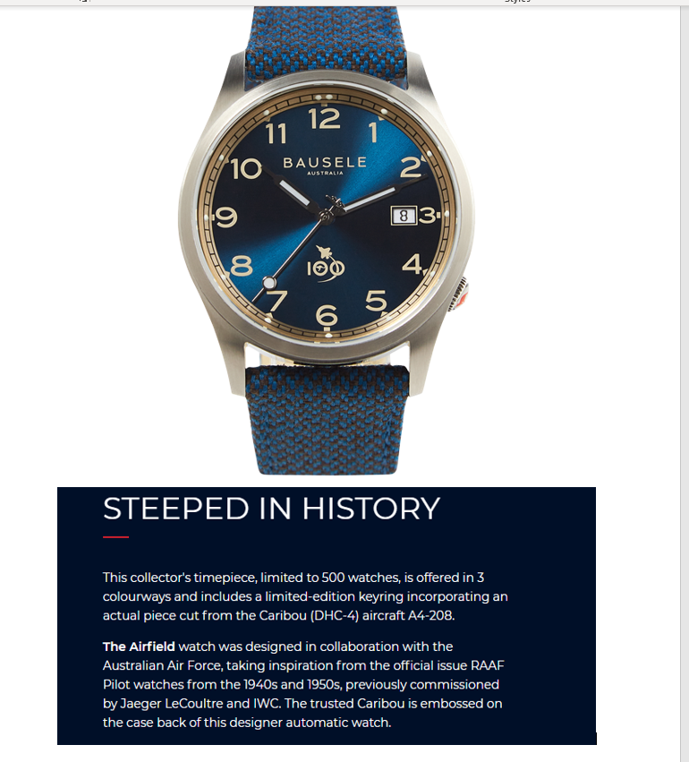
Oaks Felix hotel short walk from the Jade Buddha - https://be.synxis.com/?Chain=18336&configcode=OAKS&themecode=OAKS&brand=Oaks&currency=aud&hotel=70516&arrive=04/24/2021&promo=WALLABY
Use Wallaby promo word when you book
Andrea and I and Peter Gleeson have already booked at the Oaks Felix.
There will be no Jeeps only golf buggies. If you require a ride please let me know as we must fill out a registration form.
Any queries please ring me on 0408 872 736 or email wallabysam14@gmail.com
Cheers

