ANZAC DAY
We step off at 9:45 a.m. We form up in Charlotte Street. Please be there no later than 9:30 a.m.
It would be advisable to have a disposal mask in your pocket and water should be available.
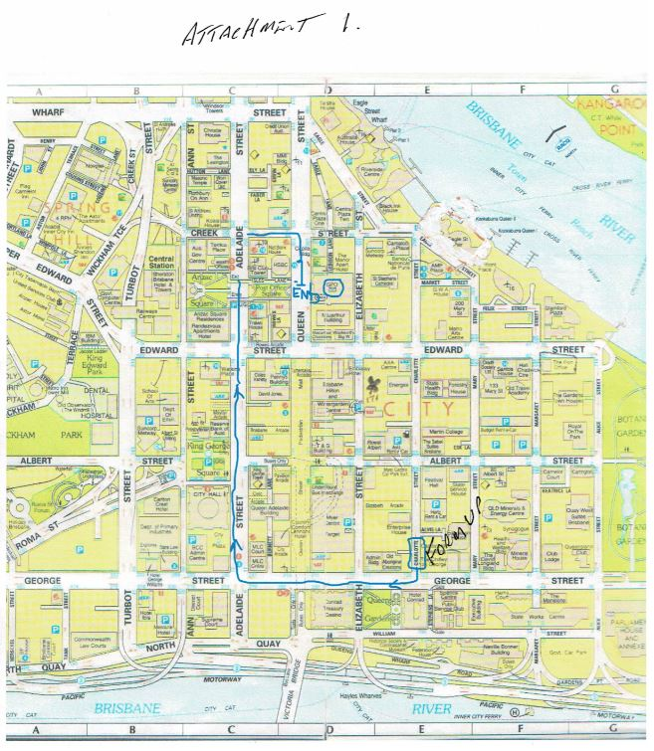
This is important re Jade Buddha. It is cashless. You will need your credit card, bank card or use of phone to pay for drinks etc.
You must check in. You can download the check in QLD app and download it to your phone. Alternatively you can use the Jade Budda side in code or physically write down your details. This is a Government requirement and must be followed to the letter.
The entry price is $29.00 which includes finger food, sandwiches etc. Meals will be available if you wish to purchase as per menu.
I hope as many of you who can attend will do so.

Information from Jade Budda
Hi John,
To pre-purchase tickets they will have to use this link; right click on link than click on open hyper link
https://brisbanetickets.com.au/event/wallaby-airlines-anzac-day-tickets-13162
I’ve texted it to you as well.
Just confirming from your conversation earlier today with Gary, that we will do a further discount to the Postmix. So they will now be $3.50.
Also just wanted to check when you wanted the 3hrs of food to start? I was thinking 11:30-2:30pm.

Once I have those times confirmed I’ll send over finalised menus (similar to the invitation).
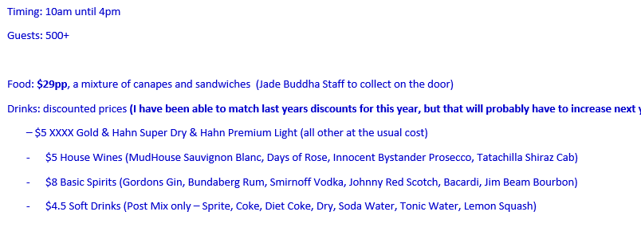

I hope to see you all there on the day.
GIGANTIC RAFFLE
There are still plenty of tickets left. There are three prizes. Tickets are $10 each.
The money we raise from the raffle will be used to offset postage expenses and general sundry costs.
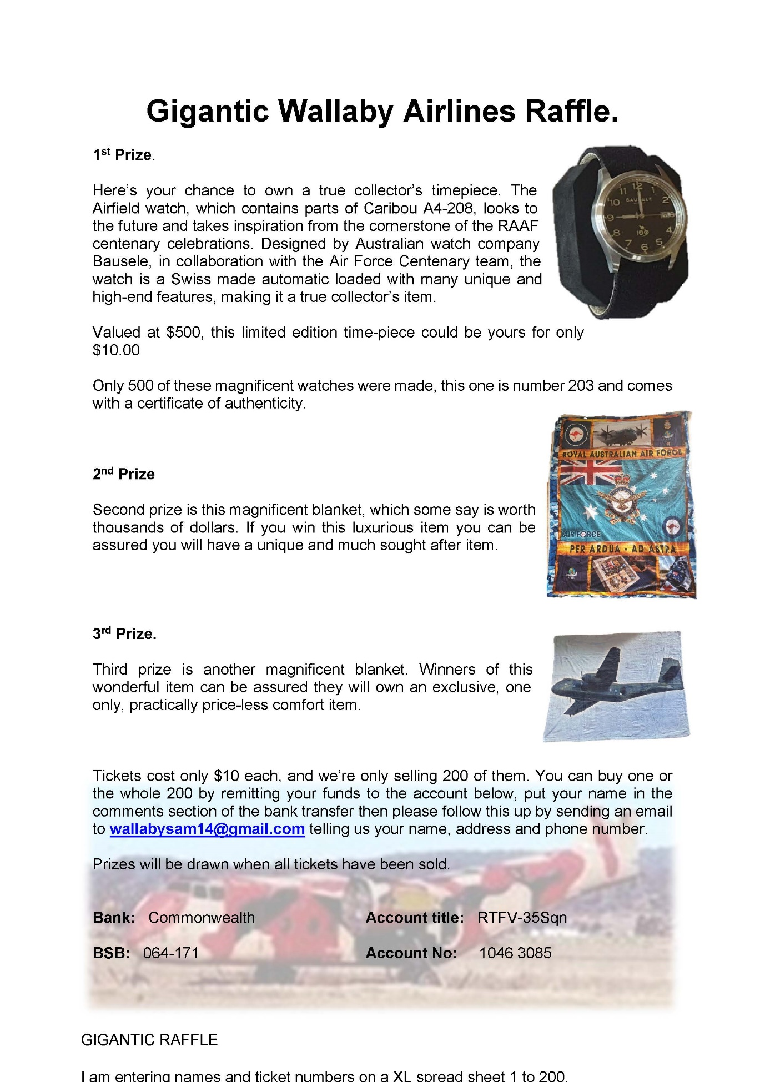
Click on link to see your numbers in the Raffle and available numbers

Gigantic raffle.docx right click on link then click on open hyper link

