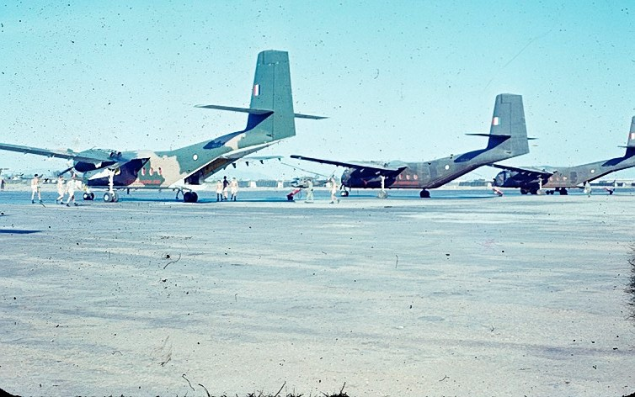RESUPPLY OF DAK PEK

By Bob Williams

On 12th January 1967, one month after my 21st birthday, I arrived in Vietnam to commence a 12 month tour as a pilot with RAAF No 35 Squadron, flying Caribou aircraft.

After 12 months, and flying 1,596 operational sorties, I boarded a Qantas Boeing 707 for the flight home. A large majority of the sorties flown in Vietnam were routine, carrying a variety of loads, which included troops, Vietnamese civilians, food, ammunition, and even live animals. Our callsign was Wallaby, and of course we were known as Wallaby Airlines. There were, however, a few very non-routine sorties.

Our base was Vung Tau, but we would occasionally be sent on attachment to Nha Trang, Headquarters of the US Army’s First Field Force. From Nha Trang, we were commonly sent on to the US Air Force base at Pleiku, where our Wallaby aircraft would fly to various US Special Forces camps along the Loas border, carrying our usual variety of loads. Some of these sorties were quite hazardous.

On Sunday May 28th, 1967, Flt Lt Dick Brice and I, together with our Load Master and assistant, flew from Nha Trang to Pleiku, stopping along the way at another small airfield. We arrived mid afternoon in poor weather, with a low cloud base, and landed via an instrument approach. There was no other activity on the airfield, which was largely deserted. As we commenced securing our Caribou for the overnight stay, we were approached by a US Major from the Air Lift Control Element. He informed us that the Special Forces Camp, Dak Pek, was under attack, and urgently needed a resupply of ammunition. He further informed us that he had no crews available to attempt the resupply.

We were familiar with Dak Pek, previously having landed there several times. The base was manned by a few US Special Forces soldiers, and an equal number of Army of the Republic of Vietnam (ARVN) troops. Dick, myself, and the two loadies discussed the chances of being able to find Dak Pek, given the low visibility and cloud base. There was also the likelihood of coming under fire while landing at an airfield which was under attack. We decided to attempt the mission.

Dick, as the more senior pilot, elected to fly the aircraft to Dak Pek, with me navigating through the valleys at low level to avoid the cloud. I was to fly the return leg, which we could do at altitude, and land at Pleiku via an instrument approach. The load was a pallet of ammunition, which was desperately needed to enable the camp defenders to hold off the VC attack through the night. Our Load Master suggested that the best, and safest, method of delivery, would be to strap the pallet onto rollers, with forward and aft restraints. If we could find, and land at Dak Pek, the cargo door would be opened and the ramp lowered during the final approach. After turning at the end of the runway, we would then immediately commence a take off. As we approached the camp gates, approximately half way along the runway, the crew intended to cut the restraints and push the pallet out of the door. Sounded good in theory. Now all we had to do was find Dak Pek.
With the tops of the valleys obscured in cloud, we flew at tree top height away from Pleiku. I studied a topographical map to keep us on a path toward Dak Pek. Dick struggled to keep us visual under the cloud. If we entered cloud we would have no choice but to climb steeply out of the valleys and return to Pleiku without completing our mission.

Fortunately, we found the camp. As we approached the camp, I contacted the US troops by radio to tell them of our plan. We were in luck. The majority of the attacking VC force were on the opposite side of the camp to the airfield. I guessed the reason being that there was no cover for the VC on the airfield side. As we pulled up over the last ridge, the sounds of the battle could be heard over the noise from the aircraft engines. The Load Master’s plan worked perfectly. Dick dropped onto the short dirt runway, and using reverse thrust and wheel brakes, slowed the aircraft at the end of the runway, swinging around for me to take over and commence the take off. As we roared past the camp gates, a jeep, with a rope trailing behind, drove out to collect the pallet of ammunition that had rolled out of the back door.

The flight back to Pleiku was uneventful, and after landing via an instrument approach, we discovered that the airfield was deserted, apart from the guards.
After securing the aircraft we jumped into our jeep for the short ride to the camp for an overnight stay. The next day we were told that Dak Pek had survived the night and that the VC had abandoned their attack. Good news. Amazingly, the aircraft had not taken a single hit. We really had taken the VC by surprise.

Postscript: In recognition of the support that No 35 Squadron crews provided to US Special Forces during the Vietnam War, the US Government awarded the US Air Medal to aircrew of No 35 Squadron Vietnam.

