The Hung-Up LAPES
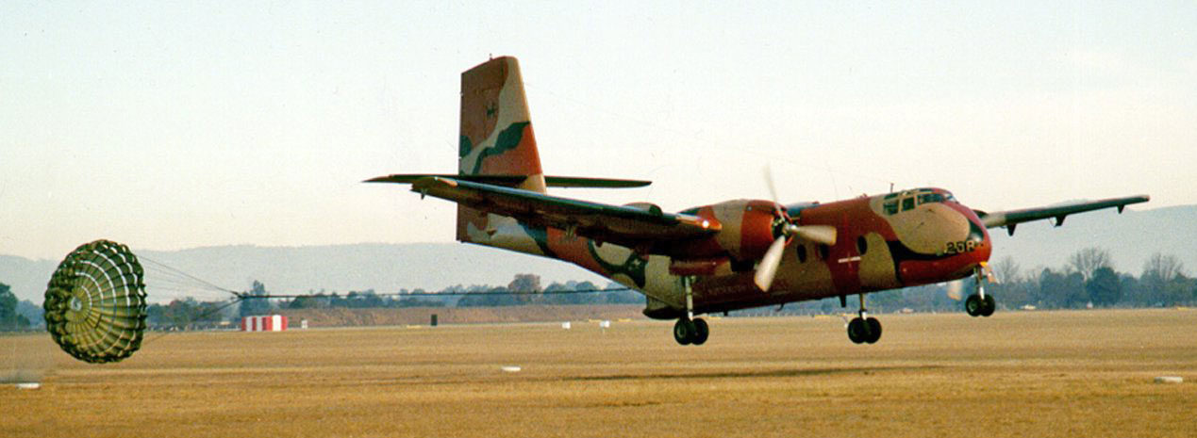
The de Haviland Canada Caribou first flew in 1958. The Royal Australian Air Force (RAAF) received the first three of its Caribous in March 1964. By the end of 1964, the RAAF had 18 of the 25 it initially ordered. Six of which were deployed to Vietnam. Those six brand new Caribous (a seventh was added in 1965) were the first RAAF aircraft into Vietnam. And the last out.
With their rear doors being capable of being opened in flight, the Caribous were able to use a new cargo delivery technique called, Low Altitude Parachute Extraction System (LAPES). The Caribou would fly low over the drop site with its landing gear down and its rear doors open. The cargo pallet to be delivered had a drag chute attached to it. And at the Calculated Air Release Point (CARP), the pilot would press a button on his control yoke. That’d release the chute from a small bomb rack located in the rear ceiling of the cargo hold, allowing it to fall out the back of the aircraft. The chute would open. Then pull the cargo pallet out of the aircraft, so the pallet could plop about one meter onto the ground and skid to a halt.
So why the hell would we do this with 800 liters of fuel, you ask?
Because the troops on the ground needed fuel. That’s why. And if we delivered it with a normal, higher altitude parachute drop, the fuel would be hanging in the sky for a minute or more for the enemy to shoot holes in the drums. And if the enemy had tracer rounds. Crikey, it could get lethal for our troops on the ground, real quick.
It usually was fuel in 200 liter drums that we were delivering by LAPES. Four of them on their sides, strapped onto a pallet. The drag chute that pulled the pallet out, was about 25 feet (8 meters) across. If the pallet got stuck and hung up on the way out, that 25 foot drag chute, which was now attached to the aircraft, became a serious problem. The Caribou had enough power to keep flying with a hung up load and a drag chute out the back. But it was a struggle. So the chute had to be cut free as soon as possible.
Simple, eh? Well no. It wasn’t. You see that pallet with four, 200 liter fuel drums on it, had to be secured before anyone could go behind the drums to cut the chute’s attachment strap. So we had special procedures that’d minimize the risks.
LAPES procedures in a Caribou, required a crew of four. Two pilots. One to fly the aircraft, the other to navigate. And two crewies in the back to handle the cargo. Two rows of rollers were attached to the floor. When loading the aircraft, the flat pallet of four drums on their side, was put on the rollers and rolled up under the wings to a low barrier that’d stop it going any further forward. The pallet then had a special, short strap attached from the rear of the pallet, to the floor. That strap would be the final restraint holding the pallet in place during the last few minutes of the drop run. There was a knife blade taped to this strap that would cut the strap when the chute deployed, thereby allowing the chute to drag the pallet out of the aircraft.
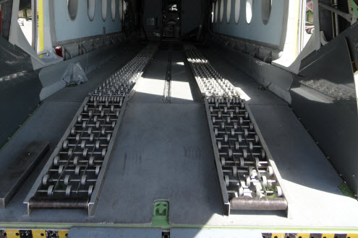

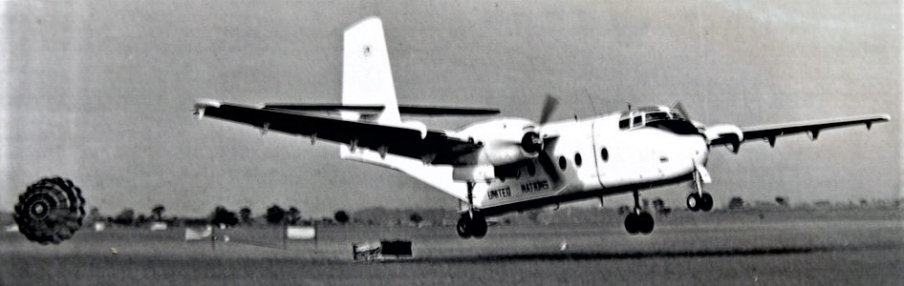
With the pallet in place and rigged for the extraction, the load was then further secured with 5,000 lb tiedown straps for the takeoff and transit flight to the drop zone. When all that was done, another three 5,000 lb tiedown straps were secured to floor tiedown points forward of the load, with the three loose end hooks taped together so they could be used quickly as one emergency restraint, should they be needed.
Planning and preparation were the secret to successful LAPES operations. Apart from training and airshows, real life LAPES drops were normally only made in combat zones. So while the crewies prepared the aircraft, the pilots planned the flight. Invariably planning to fly as low as possible to minimize exposure to ground fire. These low level flights through hostile territory were hard on the crew. The pilot flying was continually having to make control inputs to avoid the terrain. The pilot navigating had fewer references he could use to confirm where they were. And the crewies working in the back had to contend with a floor that was at times, pitching and rolling worse than any ship at sea.
Despite that, with everything strapped down and secure, flights into the drop zones were pretty straight forward up until the last five minutes. But with five minute to go, the crewies began removing the safety pins and straps. Preparing the aircraft and its load for what was a safe procedure, if nothing went wrong.
With one minute to go, both crewies would be in front of the load with their safety harnesses attached to floor tiedown points. The landing gear had been lowered. And the rear doors were opened. The second crewie was positioned immediately in front of the load, with the three emergency restraint straps in his hand, ready to snap them onto the big D ring that’d prevent the load leaving, should the drop be aborted. The lead crewie was positioned at the manual release handle for the chute, as a back up to the pilot’s electrical release. When all was in place, the lead crewie told the skipper, “The load’s live.”
The skipper would advise the crew when he was ten seconds from releasing. And then at the release point, he’d say over the intercom, “Execute!” whilst pressing his red release button. The navigating pilot would turn on the green drop lights in the back as a visual backup to the intercom call. And the lead crewie would activate the manual release. The chute would drop out of the bomb rack it’d been in, and lob out the back door, dropping down to hit the ground. Contact with the ground at about 150 km/h, would burst the bindings holding the chute’s cover together, while bouncing the unravelling chute back up into the slipstream behind the aircraft’s tail. The opening chute would fully open with a hell of a bang. The attaching strap would snap tight. The knife on the last retaining strap would cut that strap. And the full force of the chute would be applied to the load. Those four drums would roar out of the cargo hold at an instantaneous separation speed in the order of 100+ km/h.
If you’ve ever stood with your toes on the edge of a railway platform while a freight train went by at over 100 km/h, you’ll have an understanding of the experience.
When the load had cleared the aircraft, the lead crewie would call over the intercom, “Load’s gone.” The skipper would climb away, raising the gear and flaps as he went. The lead crewie would close the rear doors, and both crewies would commence cleaning up the tiedown straps and such while inspecting for any possible damage.
But on the day I’m telling you about, that didn’t happen. On that day the LAPES drops were being organized by the Air Movements Training and Development Unit (AMTDU) at RAAF Richmond, NSW. Because the AMTDU Boffins wanted to know exactly what was happening during the execution of LAPES drops, everything being done that day was filmed by cameras both on the ground, and in a chase aircraft that was flying loose formation with the drop aircraft. The aircraft was loaded at Richmond, then flown to the Londonderry drop zone, which was a clearing in the scrub a few miles South of Richmond,
Everything went to plan. Up until the chute hit the ground. The bindings didn’t burst. The chute bounced up into the slipstream wiggling and wobbling about at the end of the attachment strap. But it did not deploy.
The lead crewie called, “The chute hasn’t deployed. We’ve still got the load onboard.”
The skipper called, “Abort the drop. Secure the load.”
The second crewie snapped the three emergency straps onto the D ring.
And BAMMM! The chute opened. The knife cut the final restraint. In the blink of an eye, the load travelled about two feet before the three emergency straps slammed it to a stop. And the lead crewie called, “Chutes deployed, but the load’s hung up.”
In a heartbeat, the flight had gone from being a routine procedure, to being bloody dangerous. There were trees in front that the skipper had to clear. He pushed the throttles as far forward as they’d go, and raised the nose.
In the back, the crewies knew there were trees. They also knew that the chute was the only thing stopping the load from coming forward. So both of them were working frantically to get tiedown straps onto the load. Because if they hit the trees and the load wasn’t tied down, the 1,200 kg pallet would come crashing forward to kill all four of the crew.
After what seemed to be an eternity, but was in fact less than a minute or so, the lead crewie called, “The load’s secure, Skipper. You ready for me to go behind it and cut the chute free?”
“Not yet, Guys,” the skipper called back. “I’m climbing to 500 feet and turning to go back over the drop site. If we cut it free overhead the site, the Boffins’ll be able to recover it. And maybe they’ll be able to work out why it didn’t deploy like it’s supposed to.”
Once over the drop site, the lead crewie went behind the drums and cut the chute free. Released from the horrendous drag of the chute, and with the rear doors closed, the crew returned to Richmond.
All further drops for that day, were cancelled while the Boffins rushed the film they had, through their dark room. Later that afternoon, everybody who’d been involved in the drop were invited into the viewing room to see what’d happened. It was during this viewing that the crew who’d flown the exercise realized how close they’d come to disaster.
The camera that’d been on the ground at the drop site, showed the caribou struggling to clear the trees. The drag chute clearing the trees by only a few feet. It was obvious on the film, that had the chute caught the trees, the caribou would have been snatched out of the sky. Slamming into the ground like a fly swatter.
Which proves once again: It’s better to be lucky than good.

