Update Nov/Dec
It may be possible to hold a reunion in Townsville in June /July to coincide with the Townsville event planned by Chas Van Huslsentop once the COVID situation becomes clear. I will confirm dates, book accommodation, buses, ETC. It will be open to anyone who has been involved with the Caribou.
Caloundra Air Museum A4-173
The Caribou was badly damaged in a storm at the museum. Trev Benneworth volunteered us to help with the repairs. It needs to be evaluated to see what needs to be done. Craig Fenton, Matthew Burgoyne are current serving 35Sqb members attended the Museum for two days and worked on repairing some of the damage. The Amberley Aviation centre has been approached and I believe they are going to assist with the repairs. The damage needs to be fully accessed and an action plan formulated prior to any further work is attempted. It may be the case that the museum can apply for grants to assist with the repairs. It also needs an annex to cover and protect it in the future.
Wayne Mathews has contributed some stories to our web site. Some have been put on the web site whilst others will be on our web site shortly. Thanks Wayne.
ANZAC DAY Jade Buddha
It is a requirement from liquor license Qld that we have a letter from the RSL so that we can have our function at the J/B. The SAS Assoc. has sent a letter to the RSL, and I have included us in their letter. Attached below is a copy of his letter.

AUSTRALIAN SPECIAL AIR SERVICE ASSO CI ATIO N QLD INC
ABN 98 900 389 321

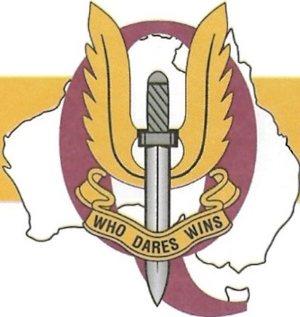

The Australian Special Air Service Association Qld Branch 48 Frampton Street
Alexandra Hills QLD 4161

/ Lf October 2021

Mr Johnathon Cole
Key Event and Appeals Manager
Returned and Services League Queensland

POST ANZAC DAY MARCH FUNCTION

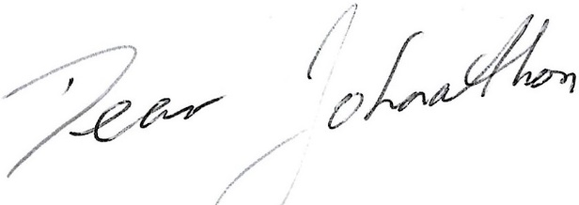

Following a vi 1t by the Liquor and Gaming Authority last ANZAC Day, we are now required to seek approval from the Returned and Services League Queensland (RSL) to hold a function following the ANZAC Day March.
,_
On behalf of the following Ex Service Organisations, I seek your approval for The Australian Special Air Service Association Qld Branch, The Queensland Commando Association, The Royal Australian Navy Clearance Diver Association and 35 Squadron, Royal Australian Air Force Association, to hold a post ANZAC Day March function at the Jade Buddha, Eagle Street, Brisbane. The Jade Buddha has been the traditional post march gathering point for our Associations over the past number of years serving food and refreshment to the veterans. Your assistance in gaining approval for this to continue would be greatly appreciate d.
Kindest regards,

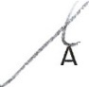
I an Bowen, OAM President
Australian Special Air Service Association Qld Branch

Jaelle has been our coordinate for the last four years. Jaelle has moved on to bigger and better things. I have met our new coordinator and we are in good hands. I am looking forward to working with Abbey.
35Sqn Amberley Scott Egan will be leaving 35Sqn in January and we will welcome the new C/O next year. Peter Gleeson and I had a dinner with some 35Sqn members at the Prince Alfred Hotel.
Those in attendance were CO Scott Egan SENGO SQNLDR, Justin Van Beuningen, WOE WOF Glenn Bennet and FGST John Fay Ev Cannard. I hope they enjoyed the dinner as we certainly did. I told them a few stories of some of the things we all got up whilst we were in Viet Nam. The Kero Kid name came up, I can tell you his name, but I’d have to kill you. I think the guys from 35Sqn enjoyed the tall Tales and they are still speaking to me
I have not given up on more 35Sqn current personal joining our Assoc to continue the history of 35Sqn.
Below are the wood models of all the Aircraft 35 sqn has operated since its inception. It was formed in Western Australia in 1942.
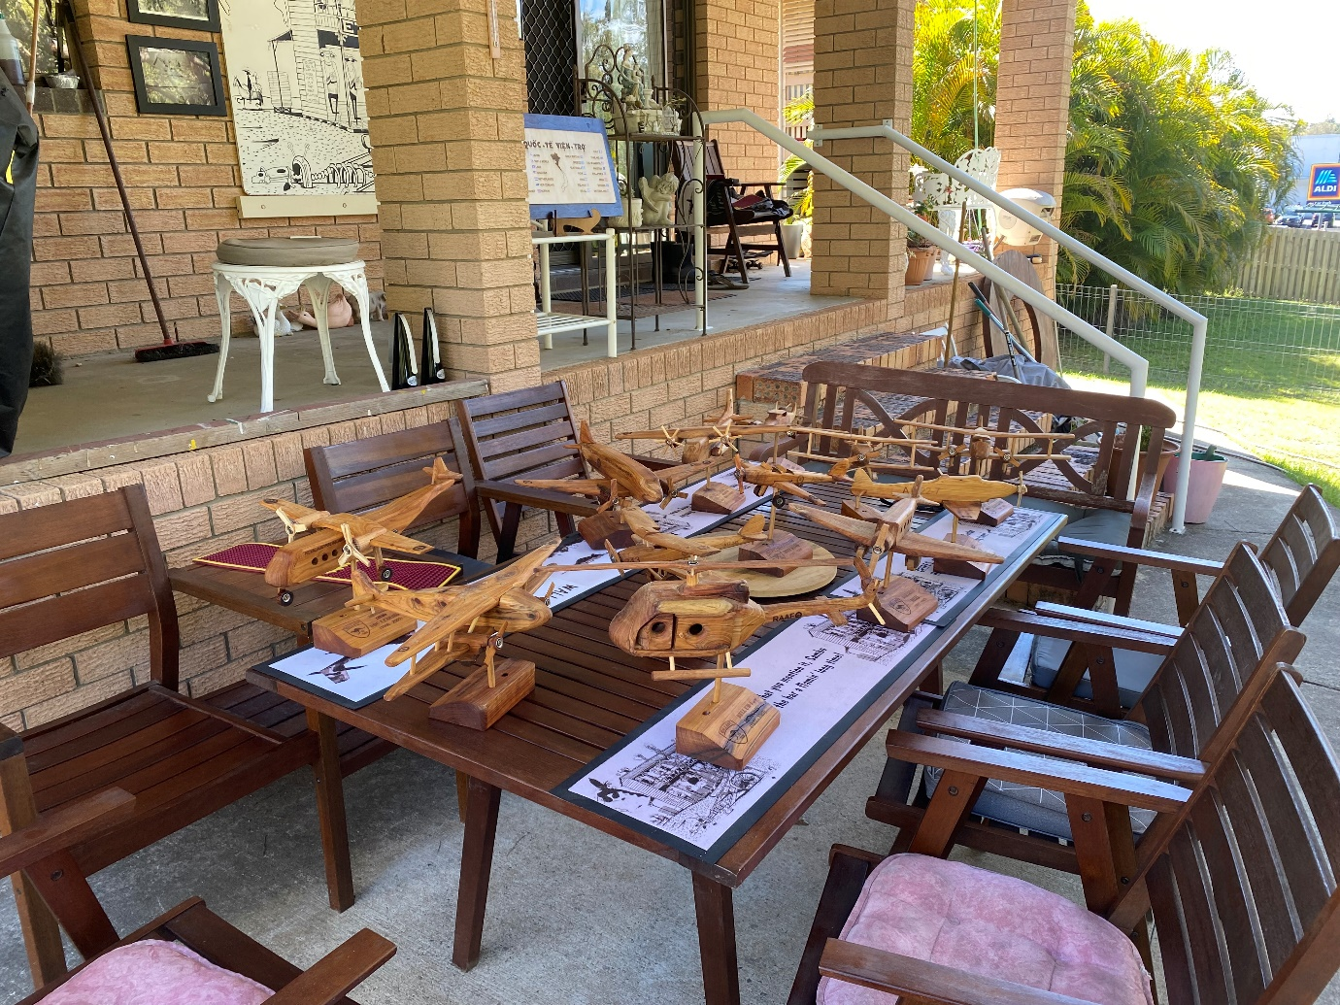

I paid for these, and they are on loan to 35Sqbn at Amberley. I would like to present the Townsville aviation Centre with a set when we attend Townsville. To offset the cost, I will do a Raffle. More details to follow regarding prizes ETC.
I don’t seem to have any luck applying for grants I might try as I would like to present all the Museum with Caribou’s.
Finances are quite healthy thanks to K.M. SMITH sponsorship. We enjoy a great relation with them which I hope will continue well into the future.
Sambo

