VAMPIRE CRASH at WILLIAMTOWN 03 MAY 1955
A79-217 from No.2 (F) OTU
Compiled by Jim Hall from a dusty ‘Crash Comic’ found amongst old paperwork.
Extract from Crash Report from SUMMARY OF AIRCRAFT ACCIDENTS APR-JUL 1955.
Approximately two minutes after take-off as No. 2 in a pairs formation, the pilot heard a strange noise and the Fire Warning Light came on. He immediately turned back towards the aerodrome, sent out a “MAYDAY” call and carried out fire drill. The No. 1 informed him that flames were visible at his starboard wing root.
The approach to the airfield was high so “S” turns were carried out and the undercarriage selected down. The aircraft came over the end of the strip at 1000 feet and so the pilot carried out a 360 degree turn to port. The flaps would not go down nor would the starboard wheel extend so the pilot selected wheels up. Approaching the end of the runway the turn was steepened whereupon the aircraft stalled. The port wing stuck the ground and the aircraft cart-wheeled, finally coming to rest 200 yards from the point of impact.
Cause and Comments
Although the aircraft was severely damaged the pilot escaped with minor injuries. (See photographs in the supplement to the Summary). This is an excellent example of a correctly fastened safety harness saving the pilot from serious or fatal injuries.
The cause of the forced landing was fire in the air. The accident resulted when the aircraft stalled at about 25 feet during the pilot’s efforts to carry out the forced landing on the runway.
The fire started in the starboard flap well. It was apparently caused by an electrical short between the lead or leads running from the fuse to the generator cut-out, and part of the flap (as the flaps operated, the electrical leads in this area were rubbed both on the way up and down).
It appeared the tank immediately in front of these had leaked fuel to dampen the wires, or area around the wires, where the short had taken place. The fire spread to fuel which had entered the starboard boom.
The pilot, in his natural anxiety to get the aircraft on the ground, tightened up the final turn to such an extent that the aircraft stalled. His actions were probably influenced by a Vampire fire the previous week when only a speedy return to the base avoided serious consequences.
The unsatisfactory feature of the flaps rubbing the electrical leads has resulted in an improved inspection being introduced at the manufacturers.
CATEGORY: Miscellaneous- faulty aircraft construction (outside of Service).
A79-217 | 4068 | FB.31 | Served with 2 OTU.  Crashed RAAF Williamtown 03/05/55. Pilot PLTOFF M K Lyons.  Approval given 13/07/55 for conversion to components.
Entry in Squadron Operations Record Book above states the bare details.

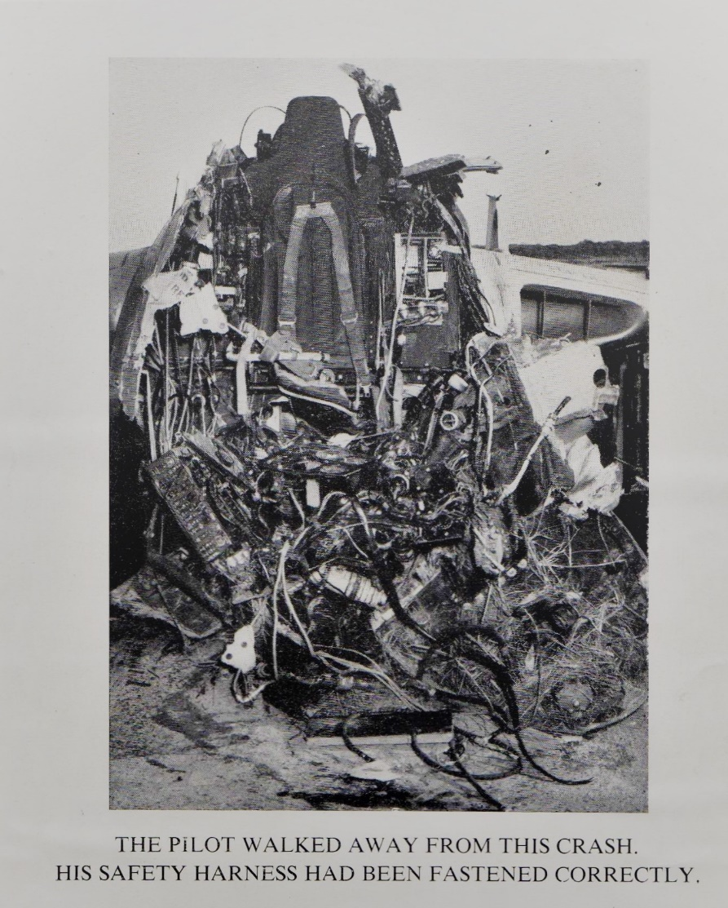
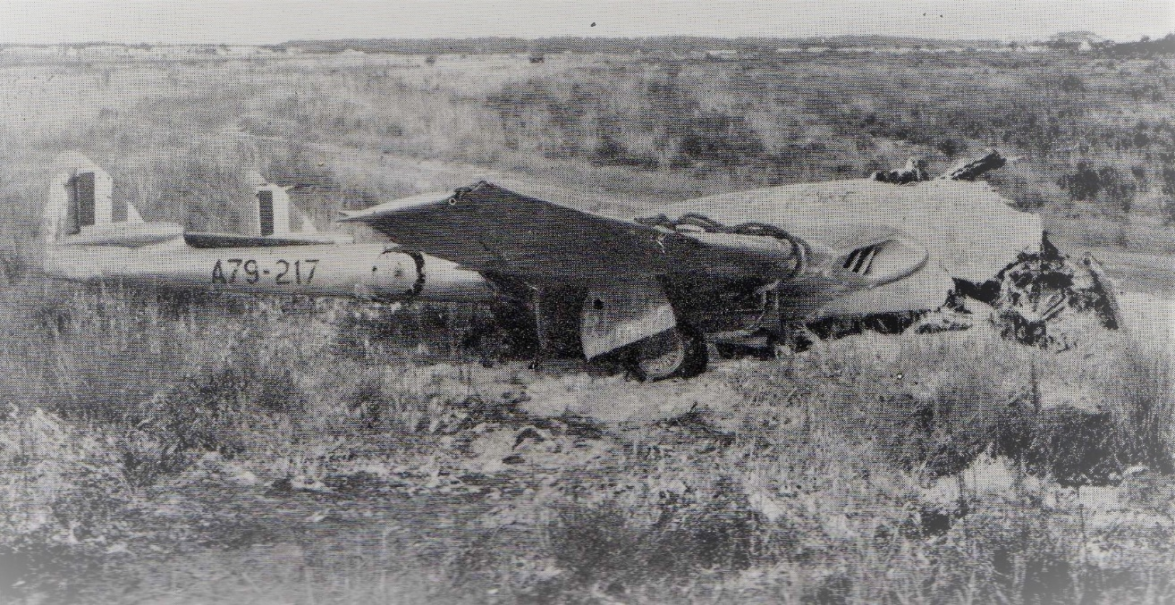
The single seat Vampire (Mk 30) first flew in 1949 and followed the Meteor as the second British jet built and did not have the luxury of an ejection seat. This picture surely has to be the best advertisement for the value of wearing a seat belt.
For those who never flew or worked on the Vampire, the fuselage was built mainly of wood which indicates wartime metal shortages. Probably fortunate for the pilot, this took the impact and then tore away.
The pilot was Michael Kevin Lyons who unfortunately passed away on Bribie Island in Queensland in 2006. His version of events would have made riveting reading.
He had many friends and was much admired by all who knew him, reflected in the response I received from the greater RAAF fellowship when I asked if anyone knew him. I have received so much information; some factual, some saying what a great bloke he was to know and fly with which has resulted into expanding on Michael’s (fondly known as Mick) life. If nothing else, this adds to the human side of these sort of events which is normally missing. He retired as an Air Commodore in 1982.
A79-217 looking a bit worse for wear.
GROUP CAPTAIN MICHAEL KEVIN LYONS (1932-2006)
Please note that I have tried, where possible, to reproduce the letters received by me in their original form. Readers will note some discrepancies as they were produced from old memories and handed on stories. In my mind, this only adds to the Human Story behind dry events. Special thanks to James Oglethorpe, Ted Mildren, Peter Larard, Peter May, Peter Ring, Nev Williams, Ross Mathieson and George Franklin. Linesmen and ball boys.
Jim Hall. 3 Sqn RAAF Association Qld.
Mick’s home was Mt. Larcom in Queensland where his father was the railway Station Master. Mick attended Nudgee College and was an excellent Rugby Union player and from there to the RAAF College, graduating in 1954. He played Rugby for Victoria against Fiji in 1954. Probably born in 1932.
From the Rockhampton Morning Bulletin Newspaper (1949):

Michael Kevin Lyons, winner in the Central and Northern Divisions of the Thallon Memorial Medal in the recent Junior Public examination. He attended Mt Larcom State School, Christian Brothers' College, Rockhampton, and St Joseph's College, Nudgee. Three medals are allotted each year in the Southern Division and one medal in the Central and Northern Divisions to the children of Queensland railway employees who secure the highest percentage of marks in the examination.

As a Squadron Leader at 10 Squadron, he was awarded the Air force Cross on 10th June 1967 for his part on rescuing people from a sinking ship.

Group Captain and CO of 11 Squadron 1970-71 during the Orion P3B years.

Ex Navigator Wing Commander Peter May (retd) recalls Mick saying of the crash: “As the aircraft slid down the runway on its belly, the tarmac appeared under my feet as it wore the cockpit away.” He lifted his legs far enough to avoid injury and was able to clear the aircraft after it came to a stop. Peter says “in my 30 years in the RAAF I never knew a finer man, leader and true friend.”

An anecdote from Nev Williams who knew Mick from 1960 until his death:

I knew Mick from 1960 until his death. There was a gap for some years but he lived near me and we played a lot golf over the years. Hope the this is of some use.

This is what I can remember what he related to me of the accident:

Mick and Don Woodman, as wingman, were taking off at Williamtown, after wheels up Don reported to Mick that he had flames out of the tailpipe. Emergency declared. Ejection Seats not fitted in that time. Managed to get around the Circuit, but did dead stick wheels up landing. Mick's face hit the Gunsight, facial damage and lost a couple of teeth, exited the aircraft ran about 100 metres and collapsed. Later found 2 broken ankles. All repaired. After that Mick acquired his stutter. From memory the Control stick had a bend in it and hung on the wall at OCS.
From memory there was similar incident a few days earlier.

While at the Academy, Mick a notable rugby player, was selected for tour England. The powers to be told Mick he could go and he would be back coursed with no penalty. Mick declined the offer of selection and to his last day claimed it was the worst decision he had made, as he would have been known forever as a Wallaby instead of a Stuttering Pilot.
He was a golfer with a low single figure handicap. I played a lot with Mick and he witnessed my 2 Holes in One (Not on the same day but a year apart)

AS an aside, Mick had an exchange with the RAF at a Shackleton Squadron. They travelled by Liner to the UK first class. Mick and wife Margaret received a “Huge" allowance for cold weather clothes and evening wear. In those days first class passengers were expected to dress for dinner. Mick had to get 2 sets of Dinner Suits.

While at Kinross, much to the disgust of other pilots, Mick was selected to lead a flight of Shackletons on a round the world show the flag flight.

From Peter Larard:

I was taxying another Vampire for take off at Williamtown so was a fairly close-up visual witness of the closing stages of the crash and was also listening to radio communications on Williamtown Tower frequency for several minutes before the crash.

Firstly, the pilot’s name was Michael Kevin LYONS. He and I were No 4 Course mates at the RAAF College, 1951-54. At the time of the accident we were both course members at No 2 (F) Operational Training Unit at Williamtown. We were also close friends and had remained so until Mick died, I think of cancer. He and second wife, I think Pauline, were resident on Bribie Island, she moved not long after Mick died, all the actual dates of which are vague in memory for me!

I think Mick had shut down the single-seat Vampire MK 30 engine following illumination of a fire warning light, and was following the well-practiced forced landing pattern at Williamtown airfield. This involved aiming the aircraft through two ”key” positions which were reported to the tower for air traffic control purposes as “high key, and “low key”. Mick had passed correctly through both key positions and had his aircraft in a position ready to lower full flap and confidently expect to make a safe touchdown without power on Runway 12. I (think) the undercarriage had lowered, BUT, the hydraulic system failed to lower ANY flap as Mick was turning the Vampire onto a very high final approach. The Vampire had very effective 80 degrees of flap, the failure of which left the pilot severely in a gross overshoot position. This Vampire had no ejection seat, he had no option but to try a 360 degree turn which he nearly achieved, both in height remaining and close to completion of the turn. The left wing impacted ground off the runway with the aircraft still in about 60 degrees of bank and appeared to cartwheel several times. I could see no sign of the pilot as I passed the site on the right during my take off. Quite remarkably he was able to hobble clear with a severely damaged foot! My opinion is that Mick was able to walk clear as the Vampire’s four 20 mm Hispano guns running underneath the cockpit had helped the structure absorb the impact damage, saving the wooden cockpit area from being torn apart!

There are many stories featuring Mick Lyons during his days at the RAAF College 1951- 54. He was a very popular man, being captain for 3 years of the first fifteen. This accident remains very clear in my mind, quite to contrary of many other, indeed most, other aspects of my life!

SITREP Air Force Association NSW News and Views
I s s u e 1 3 | J u n e 2 0 2 0 P a g e | 28
Magnetic Island
from Ross (Bags) Mathieson
On several occasions in 1976 I was deployed to Townsville, this time with Iroquois A2-773, to provide SAR support for the Mirage squadron while they practiced bombing Rattlesnake Island. I
have always been blessed with good luck, and an amazing example of this occurred during the SAR standby operation.
The day started as usual with transporting the range safety officers out to their bunker on Rattlesnake Island, from the safety of which they could observe the bombing runs. As usual, we flew via a low
level lap of Magnetic Island, to take in any sights of interest, such as wildlife or nude sunbathers. On this morning, I noticed that we had passed directly over what looked like some sort of open air church service, and as we were only 100 feet AGL, the noise would have been very loud in the morning air. I thought trouble could ensue from this incident.
Sure enough, next morning I was summoned to the office of the Officer Commanding, RAAF Base Townsville; I think the OC at the time was Group Captain Lyons. As I stood at attention in front of his desk, he said that he wanted to read a letter to me that he had
received from the Magnetic Island branch of the RSL. The letter was thanking him for providing a flypast for their commemoration service on the 11th of November, and asking him to praise the pilot for his skill in timing the pass to take place at exactly 11 minutes past the hour of 11 o’clock, right in the middle of the two minutes silence. I hadn’t even realised what date it was.
The OC finished reading the letter and then said;”You got away with it – this time! Dismissed.”

Mick resigned on 14th September 1982 as an Air Commodore and retired to Bribie Island. He passed away on 8th May 2006 from cancer.

Cadet Michael Lyons (on right) on the Wirraway Flight Line.
