Suggy’s Men
If you can donate to the printing costs, it would be greatly appreciated. We have a good number of donations so far, but we need more. Please donate $50.00 and you will receive a copy of the book Edition 2. The book will go to print in mid-May. You can pay by PayPal or transfer to our bank account. You will get a receipt for your donation.
Post to John Sambrooks 18 Coles St Arana Hills Qld 4054
ANZAC DAY 2022
We were down on numbers this year due to the rain and bloody sooks. They did not want to get their hair wet what little they have. The function at the Jade Buddha went well. Thai & Diamond and the sexy grand ma performed traditional Vietnamese dances and back to the sixties rock and roll.
Our Sponsor, K.M. SMITH, also attended. We will be donating $1000.00 towards the cost of printing “Suggy’s Men”. Katrina Puranik also attended and spoke about how we are working on fixing our email problems. David Torrington, C/O 35 Sqn, addressed the function and will continue to support our Association. We also welcome 3 Sqn. They are now part of the Wallaby Airlines family. They now have the Wallaby on their uniforms.
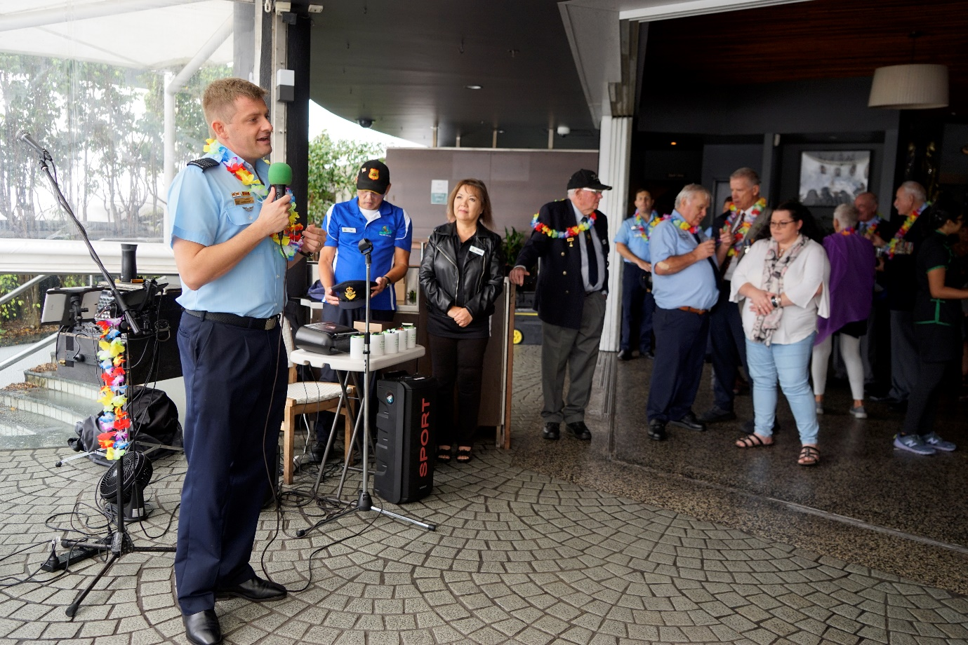
John Barry is holding the Caribou Cup Bowls Day in Bundaberg on the 10 July 2022. John’s Contact details if you require any information is 0466539441. At this stage I will be attending.
Mail chimp
Email Problems
We are trying to fix it. You need to check your junk mail please to see if you are not blocking my emails. Hopefully it will be fixed soon.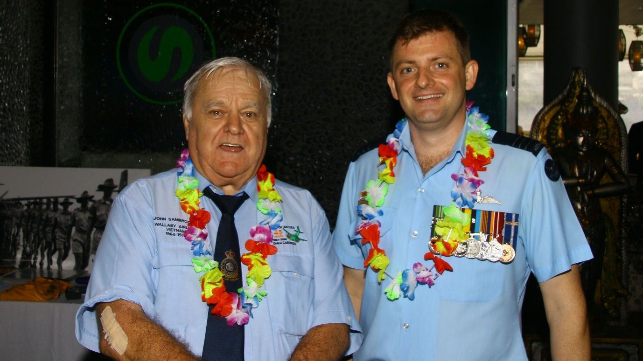
Wing Commander David Torrington and some blow in
Vietnam trip
Thai and Diamond are considering a trip to Vietnam in November in 2023. It is only a proposal now. If you think you would like to go. please let me know. I will go. Possibly play a few games of golf.
35Sqn ten years since reforming in 2013
Beetle Bailey mentioned we should be celebrating it!!
Townsville 35Sqn served at Townsville for the longest time. We could join in and have a function celebrating both events.
Wooden Model aircraft
We would like to present them to Townsville.
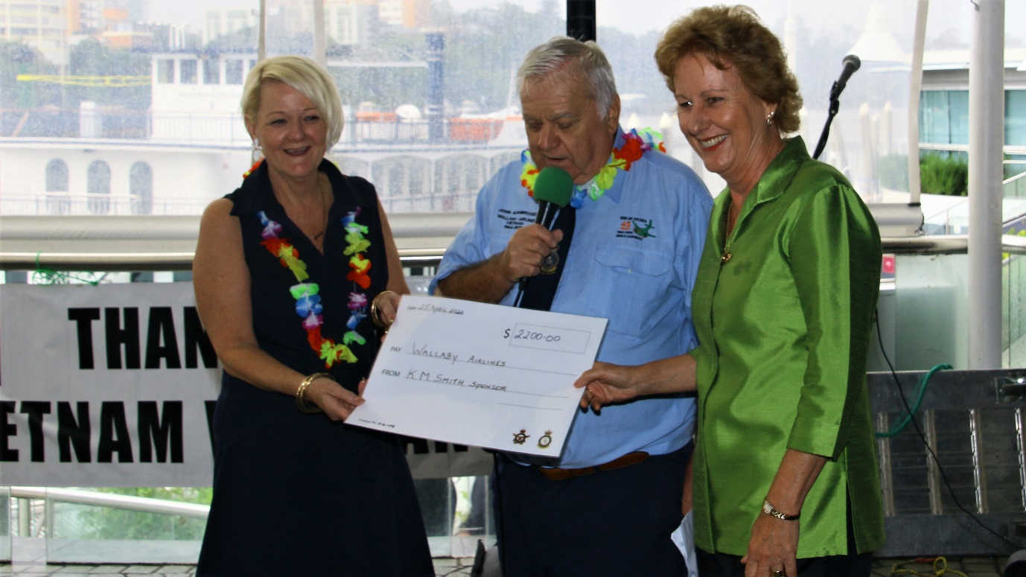
Laurel Shanley and Jennie McIntosh, our Sponsors K. M. SMITH, present cheque to us. $500.00 goes to our web master Katrina Puranik

