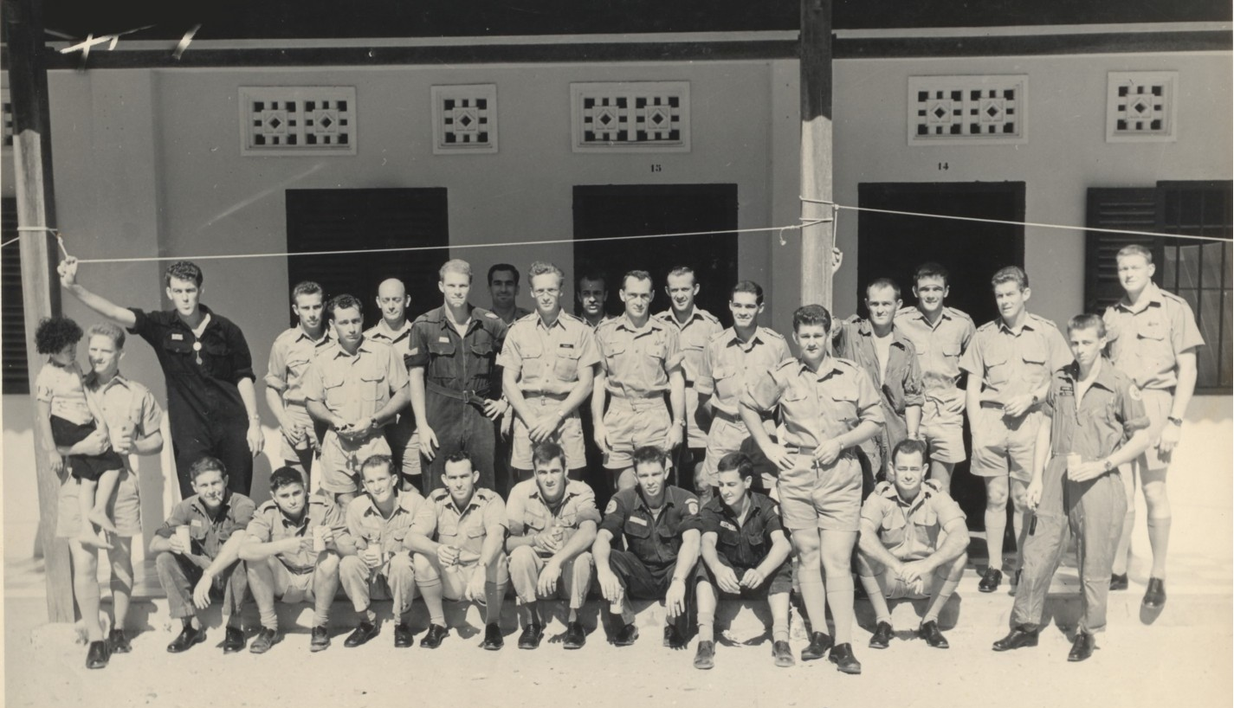
Good afternoon,

Attached is a photo from the early days at Vung Tau. We would like to include it in the new edition of Suggy’s Men but three names are unknown. Could your readers assist please?

We would also like any details and history about the photo. When was it taken? Who took the photo, etc?

Hope you can help. Please send replies to Don Pollock at dnrpollock@bigpond.com

If you have any stories, appropriate for printing, please send them in now. Last chance.

Thanks to all those who have contributed to our history.

Don Pollock

