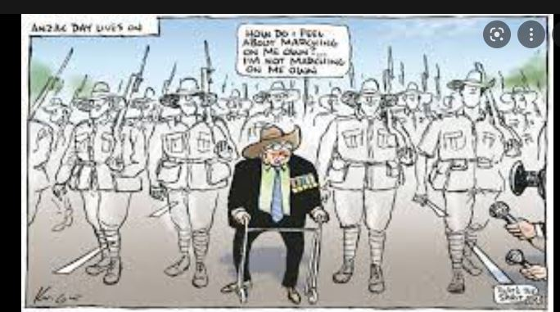
We all know about the ANZAC DAY spirit. I need the Wallaby Airline spirit, buy some raffle tickets so we can pay for the printing/I need your support as Uncle Sam says that mean you click on link to purchase tickets https://rtfv-35sqn.org/raffle/
Sambo

