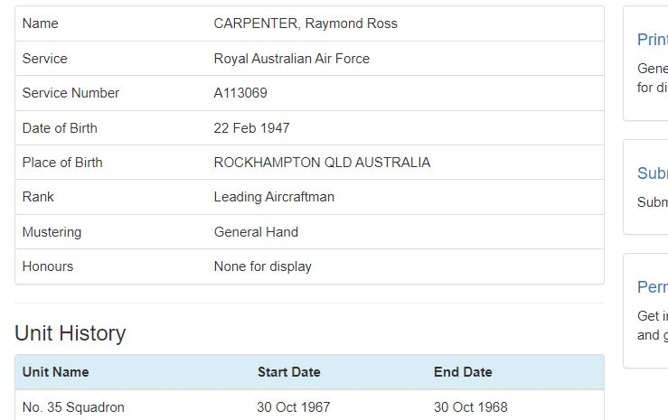
Ray Passed away mid night in Townsville cancer. As soon as more details are available I will forward then to everyone
sambo

