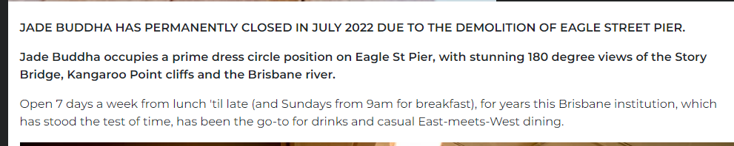

New ANZAC DAY Venue

