17 March 2023
Email to 35Sqn

I would like to get current 35 Squadron personnel involved with our website www.rtfv-35sqn.org. I have previously mentioned to some members if they would like to contribute and interest was shown, but unfortunately this has not continued any further.
It would be ideal if a current member would be interested in providing a monthly update of what the squadron is doing – like what appears in the RAAF News (without breaching protocols) that could be posted on the website. This could also include information of any social or sporting events the squadron is holding in coming months.
My aim is to build a better relationship between the squadron and our association and in the near future the possibility of a 35-squadron member taking over the website and the running of our association. I would like to make the website more accessible for everyone – past members, current serving members and anyone that has served in 35 squadron.
G’day Sambo. I’m in Italy at the moment. I’ll get Ev to chase down the photos from graduation last year in my absence .. and we’ll have a think about how we can improve the relationship between the new generation of 35 Squadron aviators and the old. I agree – we need to figure out how we can strength that connection!
David Torrington C/O 35Sqn

Torro

Pin Presentation
John McDougall and I attended the presentation, and I asked the member taking photos “if he could forward them to me to put on our website”. He agreed, I gave him my details but have not seen the photos again. I reached out but no response. You will receive a notification.
When I put a new post on our website, you will be notified by email that there is a new notice on the website.
I have been having some issues sending emails. Some emails were being received twice and some not being delivered. Katrina has come up with an email system that should fix these problems!

K.M. SMITH will be our major sponsors. Thanks to K.M. SMITH.
ANZAC Day Details
ANZAC Day
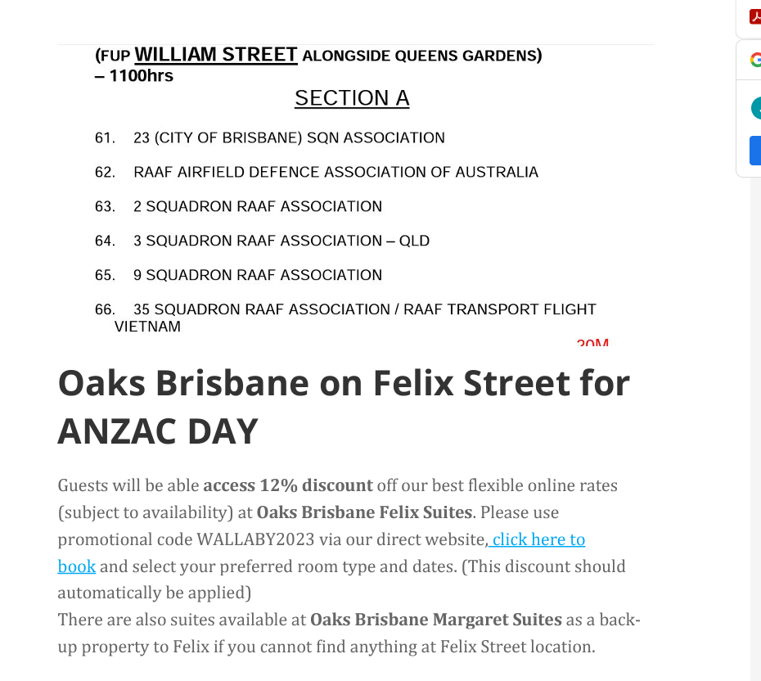
If you are not up to marching, please attend the function at Fridays, 123 Eagle St Brisbane. There is a lift at Fridays if you require to use it. Fridays will be open from 10 am for coffee etc.
Our Vietnamese friends will not be attending this year. Thai has shingles.
RAAF Lunches
They are held on the second Thursday of each month starting at midday at Fridays, 123 Eagle St Brisbane. All welcome, next date 13/04/23.
“Suggy’s Men” is available $25.00 pick up or $35.00 delivered. Visit our website www.rtfv=35sqn.org to purchase and then go to product then purchase book.
I need 52 good Samaritans with the true Wallaby spirit to purchase tickets in the wood models of the Aircraft 35Sqn has operated since 1942. By purchasing a ticket, it will help with the money we lost with the printing of “Suggy’s Men”.

Rad School Magazine
Vol 79 of the RAM is now out there. You can get your copy by going to the Radschool site (www.radschool.org.au), click on Magazines then follow the prompts to Vol 79.

Scott Egan

Former C/O 35Sqn now works for CAE based at Amberley. He is still involved with 35Sqn.
Scott is a witness for the prosecution in the kangaroo court against 35sqn.
Rocky McGregor is in hospital in Adelaide. Rocky served Vietnam 1968 GD PLT. David Fields is in Greenslopes Hospital. David also served in Vietnam 1971 ENG FITT.
Hi Tulips and Partners,
I received news from Wendy Selman that Col had a bad fall at home and is in the Highlands Private Hospital, Bowral. He is seriously ill. He is being looked after by a Spine Specialist and a Cancer Specialist. He is receiving excellent and compassionate palliative care. I have passed on best wishes from all the Tulips. Our thoughts are with Wendy and the Family. RTFRV1964 ELEC FITT
Stay Safe
Dags

Laugh
Anzac marching alone
